Michael Wayne Hymel
April 5, 1947 – March 8, 2018

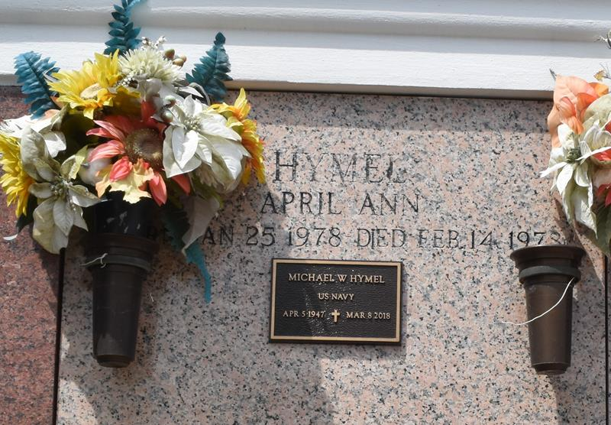

Michael “Mike” Wayne Hymel, a native of Garyville, Louisiana, and a resident of LaPlace, Louisiana, was born on April 5, 1947 and entered into eternal life on Thursday, March 8, 2018. Beloved spouse, father, father-in-law and grandfather.
He graduated from Leon Godchaux High School in 1965 and retired from Dupont. Mike was an avid fisherman, loved the outdoors, and loved spending times with his family. He will be missed by all who knew him.
He is survived by his wife of over 50 years, Patsy Weber Hymel; his daughter, Sherry Hymel Rowley (Roger); and granddaughter, Alyssa Elizabeth Roussel. He is survived by his siblings: Clyde Hymel, Kermit Hymel, Elizabeth “Betty” Hymel Ramagos, Veronica Hymel Aucoin, Robert Hymel, Kenneth Hymel, Cynthia Hymel Schaubhut, Linda Hymel Haydel and Timothy Hymel. Also survived by numerous nieces and nephews.
He was preceded in death by his parents, Arthur Joseph Hymel and Lydia Plaisance Hymel; siblings, Gertrude Hymel Jacob, Hazel Hymel Michael and Elmire Hymel Vicknair; and numerous nieces and nephews.
Relatives and friends are invited to a visitation at St. Joan of Arc Catholic Church, 529 W. 5th St., LaPlace, Louisiana, from 10:00 a.m. until a Mass of Christian Burial at 12:00 p.m. on Saturday March 10, 2018, with interment following at St. John Memorial Gardens Mausoleum. Millet-Guidry Funeral Home, LaPlace, Louisiana is in charge of the arrangements.
Millet-Guidry Funeral Home, LaPlace, Louisiana
March 10, 2018

