Carol ‘Suzi’ Ingram
May 5, 1952 – August 24, 2014

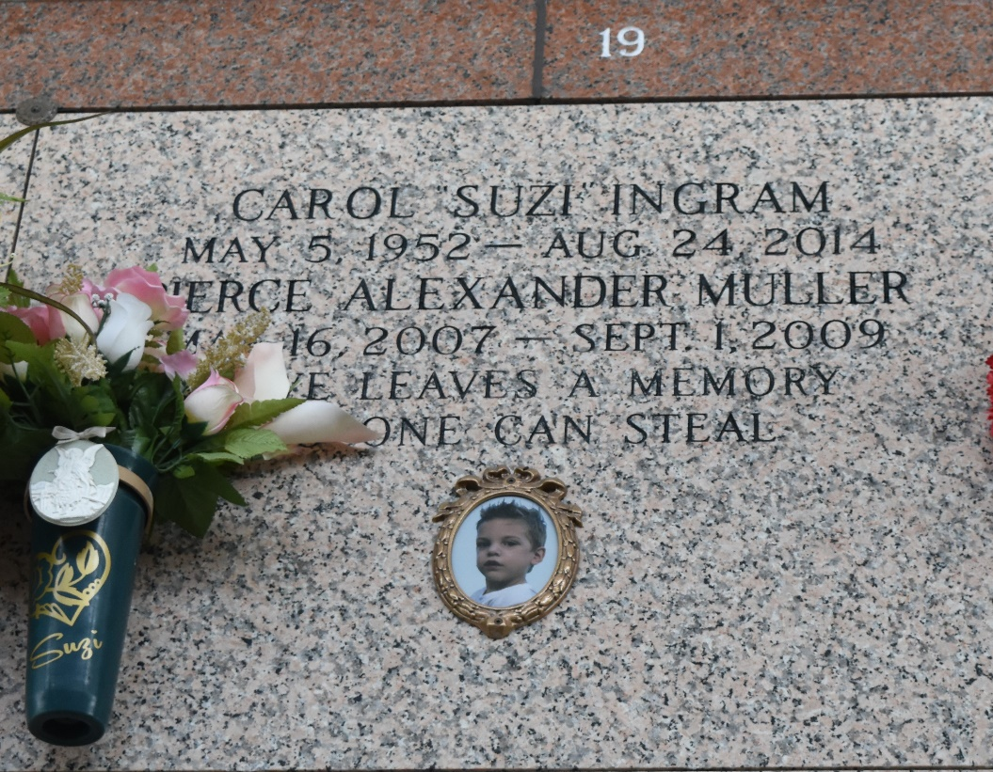

Carol "Suzi" Ingram Ourso , 62, of Ponchatoula, passed away Sunday, August 24, 2014, at her residence. She was born on May 5, 1952, in Morgan City, daughter of the late Jesse and Doris McLain Ingram . Surviving are her husband, Paul Nedos Ourso, her 6 children, Rachel Michel, Derrin Barras, Carissa Muller, Adam Ourso, Samantha Kugler, and Christina Ourso, 11 grandchildren, Katilin Gentry, Hunter Michel, Bryson Barras, Bradon Barras, Bennett Reed, Arden Reed, Madisyn Ourso, Adam Ourso, Jr., Myah Kugler, Reed Kugler, and Baylynn LaMarca, her sister, Gail Ewing, and brother, Douglas Ingram. She is preceded in death by a grandson, Pierce Muller.
Friends will be received Tuesday, August 26, 2014 from 6:00 pm until 9:00 pm at Harry McKneely & Son Funeral Home - Ponchatoula, and after 8:00 am on Wednesday, August 27, 2014 until religious services at 10:30 am in the Funeral Home Chapel. Interment will follow in St. John Memorial. A guestbook is available at www.harrymckneely.com
Harry McKneely & Son Funeral Homes & Crematory, Hammond, LA
August 24, 2014

