Brenda (August) Jackson
1941 – May 10, 2022

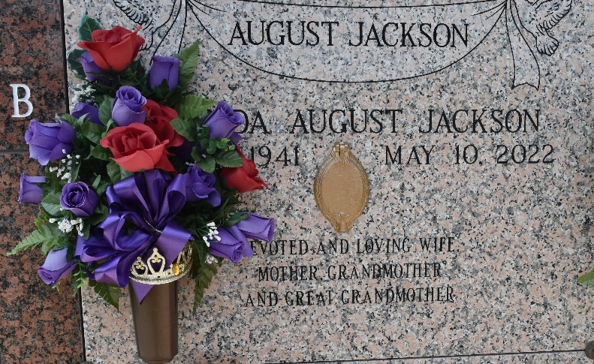

Brenda August Jackson, loving mother, grandmother and great-grandmother, departed this earthly life on Tuesday, May 10, 2022 at Our Lady of the Lake Ascension in Gonzales, LA at the age of 81. Brenda was a native of Belle Rose, LA and a resident of LaPlace, LA for over 50 years. Brenda worked for various employers in the River Parishes including Airline Motors Restaurant, Boyce Machinery and as a cook in the St. John the Baptist School System.
Brenda is survived by her 3 daughters: Arneadra August Zeno and Gaynell Balque of Gonzales, LA, and Shennetah Balque Rogers (Dannie) of Arlington, TX; 1 daughter-in-law whom Brenda treated as a daughter, Roberta Zeno August; 9 siblings: Loril Pearley Rodrigue and Louis (Mae) Pearley of Harvey, LA; Albert Harris of Plano, TX; Elsie (Allen) Parker of New Orleans, LA; Marion (Otis) Williams and Beverly August Jordan of Donaldsonville, LA; Patricia (Gerald) Parker of Baton Rouge, LA; Mildred (Clarence) Williams of Prairieville, LA; and Glen August of Belle Rose, LA; 8 stepchildren: Kolena, Ruby and Myron Jackson, whom she helped raise, Kendall (Bridget) Jackson Sr., Kelva Jackson London, Kurtrell (Rosa) Jackson Sr., Kareck Jackson, and Kedreck (Tracy) Jackson Sr.; 8 grandchildren; 10 great-grandchildren and 1 uncle, Lloyd Harris of Gonzales, LA; a very devoted friend, Glendora Ceasar of LaPlace, LA, and devoted cousin Olevia Johnson of Belle Rose, LA.
Brenda was preceded in death by her son, Pastor Donald Ray August Sr.; husband, Rev. William Jackson; parents, Freddie August Sr. and Emma Harris August; siblings, Catherine August Brown, Delta August and Freddie August Jr.
The Celebration of Life service will be held Saturday, May 21, 2022 at 11 a.m. at New Wine Christian Fellowship, 1929 West Airline Highway, LaPlace, LA 70068. Viewing from 9:30 a.m. until service time. (ONLY) Rev. Alvin McQuirter, Associate Minister of the Rising Star B.C. Officiating. CDC Covid-19 guidelines will be followed. Interment at St. John Memorial Gardens, LaPlace, LA. Professional services entrusted to the caring staff of Hobson Brown Funeral Home, 134 Daisy Street, Garyville, LA 70051. 985-535-2516.
The Times-Picayune (New Orleans, LA)
May 19 to May 21, 2022

