Freddie Jackson
April 24, 1948 – October 13, 2018

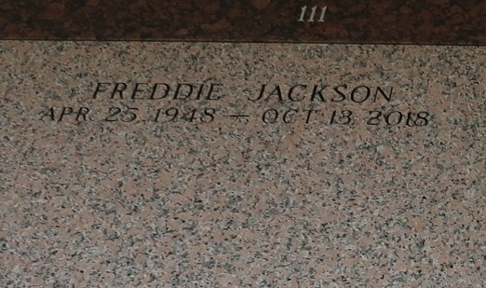
Freddie Jackson was born on April 24, 1948 in Ferriday, LA. He attended Sevier High School. He graduated from Southern University in New Orleans, LA with a degree in Business. In his youth he served as a musician for many churches. He worked for many years at Cytec until his retirement. Freddie was 70 years old when passed away of a Pulmonary Embolism following surgery on October 13, 2018 at Ormond Nursing and Care Center in Destrehan, LA.
He was preceded in death by his parents, Beatrice and Collie White, and Robert Jackson. His brothers Billy White, Nathan Wilson, Willis White, and his sister Bobby Nell Matthews and Jesse “Diddy” White.
He is survived by his Sister Ann Rounds of Lake Charles, LA; Brothers Jessie Wilson Sr. (Ruth) of Kenner, LA, Collie White (Valerie) of Charlotte, NC, Shelby Wilson Sr. (Betty) of Lake Charles, LA, LeDell “Darnell” Wilson of Charlotte, NC; his Nephew “caretaker” Charles Matthews, and a host of Nieces, Nephews, Cousins, and Friends.
Relatives and friends are invited to attend the Funeral Service at Millet-Guidry Funeral Home, 2806 W. Airline Hwy, LaPlace on Saturday, October 20, 2018 at 11:00 a.m. Visitation will be held from 9:00 a.m. to 11:00 a.m. Interment in St. John Memorial Gardens Cemetery.
Millet-Guidry Funeral Home online obit (accessed 10/17/2018)

