Gloria Yvette (Harper) Jackson
1927 – April 4, 2020

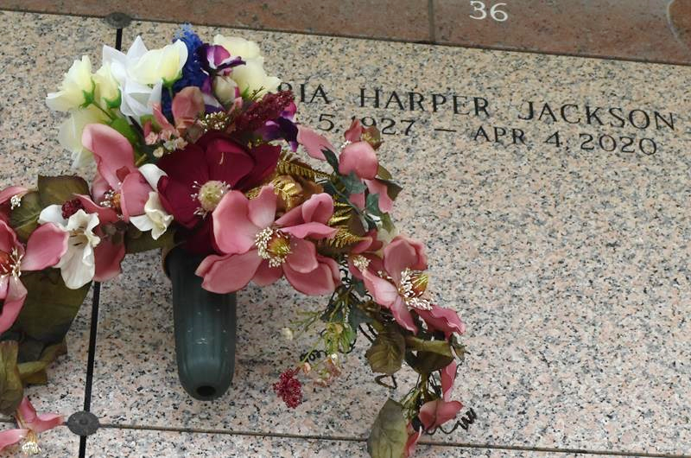

Gloria Yvette Harper-Jackson departed this life peacefully at her home with family in Garyville, LA on Saturday, April 4, 2020 as a result of natural causes. She was 92 years old. She was a retired educator in St. John the Baptist Parish. A member of the True Light Baptist Church, Garyville, LA where she served in various capacities all of her life.
Those cherishing her memory are her children; Warren H. Glass, Jr., Derek R. Glass and Darcel D. Glass (James) Gardner, Jermaine B. Glass; grandchildren, Great-grandchildren and great-great grandchildren; two sisters, Luther Mae Harper (Ernest) Pierce, DeRidder, Louisiana, Barbara Harper Sewell, Zachary, Louisiana; nieces and nephews, Cousins; God Children, Michelle Bennett, Stephanie Jones, Patricia Harper-Mutlaq; a host of other relatives and friends.
Gloria's granddaughter, Kawana Perrilloux was devoted in caring for her, she was always available with Gloria's Dr's appointments, her hospital stay and home care.
She was preceded in death by her loving husband Shirley Jackson; her parents Pastor Jake J. and Edna (Favors) Harper; three sisters, Camille Billups, Elouise Harper-Smith, Dorth Mae Harper-Triche; two brothers Jake J. Harper, Jr. and William Harper.
A viewing will take place on Friday, April 10, 2020 from 9:00 am to 11:00 am at the Baloney Funeral Home, 1905 West Airline Hwy, LaPlace, LA 70068. Due to COVID-19 and considering the safety of all, the funeral home will ensure that social distancing protocol is followed. Therefore, all visitors must follow the Funeral Directors instructions for viewing. After the viewing, the family and only the family, will proceed to the St. John Memorial Gardens, LaPlace, LA for the Burial. A memorial service will be held at a later date. Services entrusted to the Baloney Funeral Home, LLC, 1905 W. Airline Hwy., LaPlace, LA70068, (985) 224-8460.

The Times-Picayune (New Orleans, LA) - Apr. 8 to Apr. 9, 2020

