Ranu Jackson, Sr.

November 28, 1975 – October 26, 2012

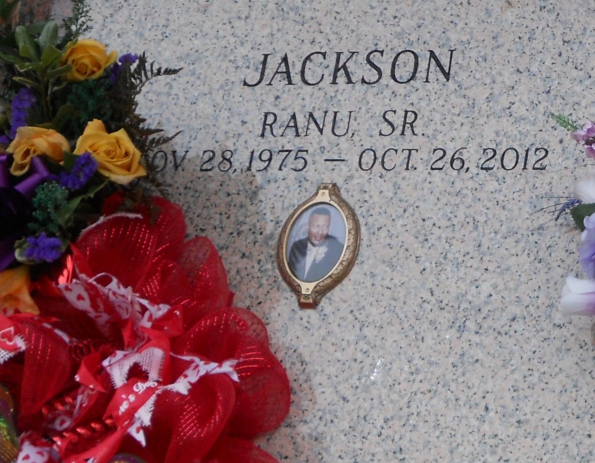

Photo by Team T Lo

Ranu Jackson, Sr. peacefully entered into eternal rest on Friday, October 26, 2012 at University of Texas Southwestern Medical Center in Dallas, TX.   
 Son of Raymond Jackson, Sr., and Margaret Wright.  Beloved husband of LaDon Barnes Jackson.  Loving father of Ra'Ahn Christina, Ranu Jr., and RaLee Christian Jackson all of Murphy, TX.  Brother of Richard Johnson, Donisha (Wendell) Riley, Rayonda (Larry) White, and Raymond Jackson Jr.  Son-in-law of Lee Chester and Peggy Banks Barnes. Also survived by a host of aunts, uncles, nieces, nephews, cousins, other realtives and wonderful friends.   
 Age 36 years. A native of Gretna, LA and a resident of Murphy, TX. Ranu was a graduate of Grambling State University with a BS Electrical Engineering Degree. He worked as a network engineer at Fujitsu Network Communication.   
 Relatives and friends of the family, also pastors, officers and members of Mount Calvary Baptist Church, Jerusalem Baptist Church of Calhoun, LA, Christ Community Church of Richardson, TX, Mount Zion Missionary Baptist Church of Gretna, LA and all neighboring churches are invited to celebrate Ranu's home going at Mount Calvary Baptist Church, 127 West 3rd Street, LaPlace, LA on Saturday, November 3, 2012 at 12 Noon. Rev. Freddie Howard, Pastor, Rev. Don White, Pastor of Jerusalem Baptist Church, Calhourn, LA, Officiating. Interment St. John Memorial Garden Cemetery, 2205 West Airline Highway, LaPlace, LA.   
Visitation at the above named church from 10:00 A. M. until service time.   
SERVICED BY ROBOTTOM

**Times Picayune (LA); unknown date**