Sonia Marie Jacob Brooks

July 25, 1969 – November 2, 2007

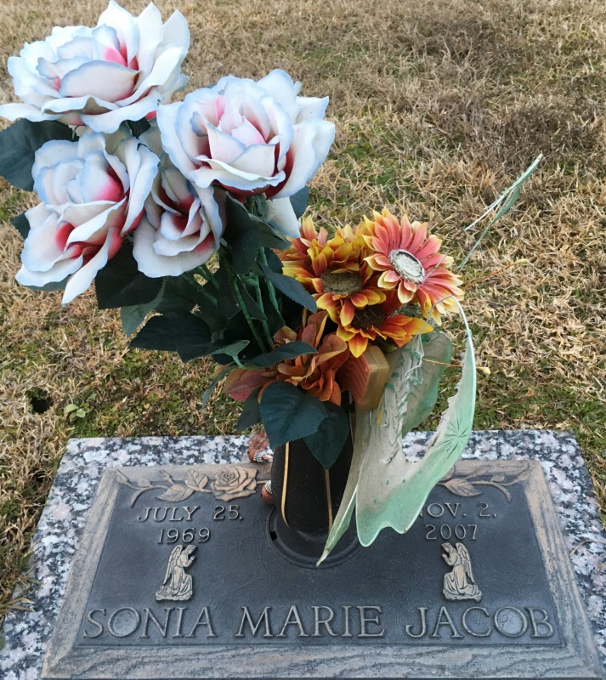

Photo by Team T Lo

BROOKS Sonia Jacob Brooks passed away on Friday, November 2, 2007 at her residence in Atlanta, GA. Daughter of Lucien W. Jacob of New Orleans, LA and Jenny Knight of Kenner, LA and step-daughter of Brenda Jacob of N.O., LA and Wayne Knight of Kenner, LA. Mother of Donovan Jacob and sister of Madeline Jacob, Lucien Jacob, Jr., Dominique Jacob and Cathy Vergara. Age 38 years. A native of New Orleans, LA. Relatives and friends of the family, also priest and parishioners of Our Lady of Grace Catholic Church, St. John Baptist Church and employees of St. John Parish School Board are invited to attend the Mass of Christian Burial at Our Lady of Grace Catholic Church, 722 Highway 44, Reserve, LA on Saturday, November 10, 2007 at 11:00 a.m. Rev. Joseph Rodney, celebrant. Interment St. John Memorial Garden, LaPlace, LA. Visitation from 9:00 a.m. until Mass time. Rosary 10:00 a.m. SERVICED BY BARDELL'S MORTUARY. Information: ((985) 535-6837.

Published in The Times-Picayune on 11/9/2007

Contributed by Jane Edson