Wayne Paul Jacob
June 22, 1947 – May 18, 2023

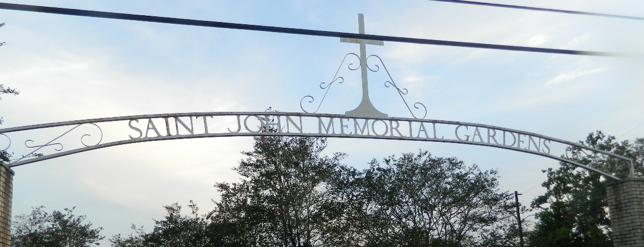

It is with great love and admiration that we celebrate the life of Wayne Paul Jacob, known to many as "Pop," and “Jaco” who passed away on May 18, 2023. Born on June 22, 1947, in LaPlace, Louisiana. Wayne was a loving, loyal, dedicated, and wise individual, who left an indelible mark on the lives of those who had the privilege to know him. A devoted husband, father, grandfather, and great-grandfather, Wayne was the epitome of love and dedication.
Throughout his life, Wayne demonstrated a passion for many things, including farming, raising and racing thoroughbred horses, shrimping, raising livestock, and spending family weekends in Grand Isle. He enjoyed spending time with his beloved wife of 57 years, JoAnn, and their children, grandchildren, and great-grandchildren. A true LSU fan through and through, Wayne was also a dedicated little league coach at Larayo, touching the lives of countless young athletes. A graduate of Leon Godchaux High School, he played football and ran track for the school, eventually marrying his high school sweetheart, JoAnn. Together, they built a beautiful life and a thriving business, as original owners of Wayne Jacob's Smokehouse in LaPlace. Wayne was employed at DuPont in Reserve.
Wayne is survived by his wife, JoAnn; children and their spouses, Julie and Scotty Stein, Joey Jacob, and Jill and Shaun Brignac; grandchildren and their spouses, Joshua and Scarlett Stein, Kelsie and Dylan Puccio, Jacob and Paige Stein, Jordin Jacob, Harli Jacob, and Joei Jacob; great-grandchildren, Aubri, Addison, Talon, Wyatt, and Rynn; and brothers, Ronald and Donald Jacob. He was preceded in death by his parents, Nolan and Beatrice Jacob.
Relatives and friends are invited to to attend the visitation at Millet Guidry Funeral Home, 2806 West Airline Highway, LaPlace, on Thursday, May 25, 2023, from 9:00 a.m. until 12:00 p.m. followed by a prayer service at 12:00 pm. A private burial will take place at Saint John Memorial Gardens, LaPlace, LA.

Millet-Guidry Funeral Home, LaPlace, Louisiana
May 23, 2023

