Keith Anthony Jeandron

August 7, 1960 – December 24, 2001

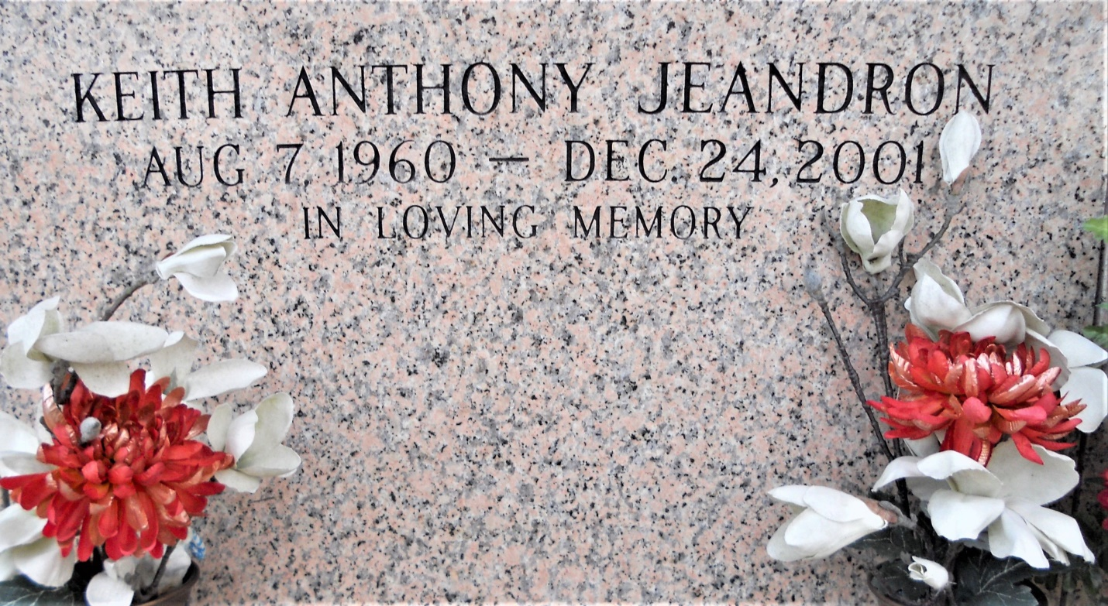

Photo by Team T Lo

Keith Anthony Jeandron on Friday, December 24, 2001 at 5:53 AM. Beloved father of Janice Marie Jeandron. son of Morris and Janice Jones Jeandron. Brother Lauren, Gary, Timothy and Daniel Jeandron. Age 41. A native of raceland, LA and resident of LaPlace for the past 30 years.  
  
Relatives and friends of the family are invited to attend the funeral services at Ascension Of Our Lord Catholic Church, LaPlace, LA on Friday, December 28, 2001 at 10 AM. Burial in St. John Memorial Gardens, LaPlace, LA. Visitation from 8:30 AM on Friday at the church until services. Arrangements by MILLET-GUIDRY, LAPLACE.

Times-Picayune, The (New Orleans, LA) - Thursday, December 27, 2001

Contributed by Jane Edson