Wilbert Joseph Jenkins
December 6, 1937 – March 15, 2017

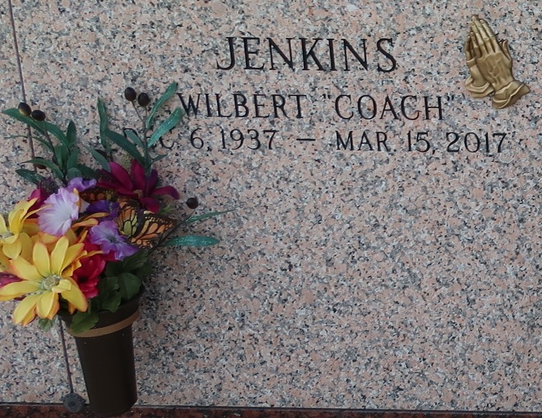

Wilbert Jenkins on Wednesday, March 15, 2017 at Ochsner Medical Center, Jefferson, LA. Son of the late Roseline Brown and Clarence Jenkins, Sr. Husband of Lorita Jenkins. Father of Cedric Jenkins, Sr., Brigitte Jenkins and Kyan Thomas (Izell). Brother of Myrtle Smothers, the late Ethel Williams and Clarence Jenkins, Jr. Also survived by 7 grandchildren, 8 great grandchildren and a host of nieces, nephews, cousins, other relatives and friends. Age 79 years. A native of Norco, LA and resident of LaPlace, LA.
Relatives and friends of the family, also pastors, officers and members of Bethlehem Missionary, Greater Plymouth Rock and Good Hope Baptist Churches and all neighboring churches are invited to attend the Funeral Service at Bethlehem Missionary Baptist Church, 146 E. 20th Street, Reserve, LA on Saturday, March 25, 2017 at 11:00 AM. Rev. Forell Bering, Pastor. Pastor David B. Carter, Officiating. Interment St John Memorial Garden Cemetery, LaPlace, LA. Visitation at the above named church from 8:00 AM until Service Time ONLY SERVICED BY ROBOTTOM
The Times-Picayune, New Orleans, Louisiana - Mar. 20 to Mar. 24, 2017

