Barry O. Johnson Jr.
July 24, 1976 – October 7, 2016

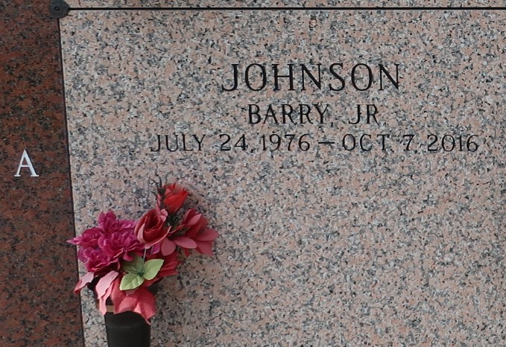

Barry O. Johnson Jr. passed away on October 7, 2016. Son of Audrey and Barry Johnson Sr. Survived by a host of other relatives and friends.

Service on Friday, October 14, 2016 at 11:00am at Revelation Knowledge Outreach Center, 125 Ash St. Laplace, LA 70068. Rev. Alfreda Devare Pastor officiating. Viewing 9:00am. Internment St. John Memorial Gardens, Laplace, La. Service Entrusted to Hobson Brown Funeral Home, 985-535-2516.
The New Orleans Advocate (LA)
Oct. 12 to Oct. 14, 2016

