Dartania Margen Johnson
September 12, 1972 – April 2, 2020

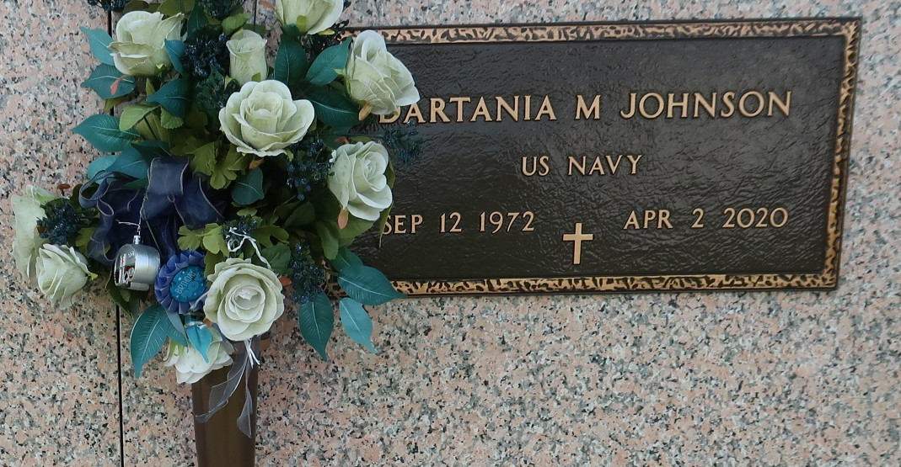

Petty Officer 3rd class Aviation Electricians Mate, Dartania Margene Johnson, a United States Navy Veteran entered into eternal rest on Thursday, April 2, 2020 at Ochsner Medical Center in Kenner, LA after he succumbed to COVID19. Affectionately known as "Uncle Da, Dar, Dart" was born September 12, 1972 in Lutcher, LA to the union of Wilbert and Rita Mae Johnson Jr. He was a native of Reserve, LA (Cornland) and resided in Laplace, LA.
He accepted Christ at an early age and was baptized at Beech Grove Baptist Church in Reserve, LA by the late Rev. Wesley Anderson Sr. As a young man, he became a member of Providence No. 2 Baptist Church in Montz, LA, under the leadership of the late Rev. Donald Brown Sr. He was a graduate of East St. John High School in LaPlace, LA (C/O 1991) and from there, he enlisted in the United States Navy. He was employed at Cargill in Reserve, LA for eighteen years as a Control Room Operator.
Dart was loved and respected by many for his outgoing, dedicated, full of life personality and was also a Co-Founder of Secret Society, a local organization founded on the roots of service and brotherhood. He leaves to cherish his memories his precious daughter Darvi Malia Johnson. He is survived by his fiance Vionne Miller, her son Taylor "TMillz" Miller, his devoted mother Rita Mae Johnson, father Wilbert (Gayle) Johnson Jr., five sisters Alecia Johnson of Reserve , LA , Chandrika Johnson of Laplace , LA , DeLois Johnson of New Orleans, LA , Danielle (Michael Davis Jr.) of Laplace, LA and Bianca Johnson of New Orleans, LA; one brother, Randy Johnson of Temple, TX, nine nieces, three nephews and three great-nieces and nephews, his God-parents Ophelia Richardson-Tyler and Jefferi Kelson and a host of aunties, uncles, other relatives and friends.
He is preceded in death by his brother Morial "Moe" Johnson, his maternal grandparents Wilson and Josephine Jones Sr, paternal grandparents Wilbert and Alberta Johnson Sr., Aunts Elmira Batiste, Thelma Johnson and Yvonne Johnson-Lumar, Uncles Warren Jones, Harold Van, Wallace, Patrick "Claude" and Wilfred Johnson and cousins Kenyara Hornsby and Amber Jones.
Pastors, officers and members of Providence No.2 and Beech Grove Baptist Church, Cargill, St. John the Baptist and Orleans Parish School Systems, Marathon Refinery, DENKA "DuPont", Orleans Parish Assessors Office ,Tulane University, State Farm Insurance Agency and LaPlace Fair Grounds, Family and Friend's, our family would like to thank you for your warmest prayers, wishes and thoughts. Due to COVID19, the family also ask that you respect governmental guidelines. To share condolences and thoughts, and to sign guest book, please visit: www.treasurefunerals.com.

Treasures of Life Funeral Services, Gramercy, Louisiana

