Delores H. (Powers) Johnson

December 25, 1940 – June 8, 2006

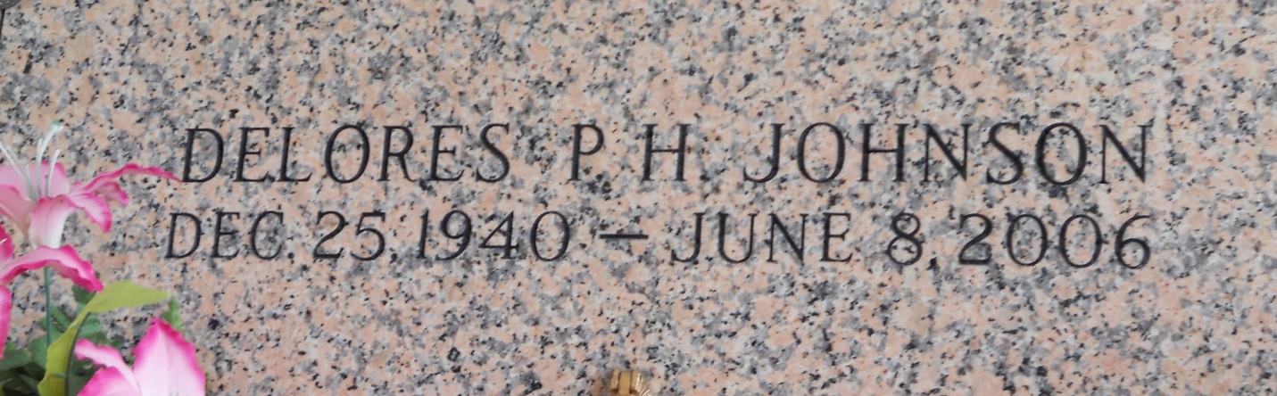

Photo by Team T Lo

Delores Johnson, a Homemaker departed this life on Thursday, June 8, 2006 in Laplace, La., Daughter of the late John and Corita Powers, Mother of Kathy Green, Stephanie Gray, John and Barry Howard, Yolanda Miles and the late Gus Howard, III, Sister of James Brown, and Leroy Powers, Mother in law of Gary Miles, Jr., and Deborah Howard, also survived by (2)step sister, (1) step brother, 19 Grandchildren, 7 great grandchildren, and a host of nieces, nephews, other relatives and friends. Age 65 a native and resident of LaPlace, La.  
  
Relatives and Friends of the family, pastor, officers, and members of Rising Star B.C. and all neighboring churches, are invited to attend the Home Going service on Wednesday June 14 2006 at 11:00a.m. From the above named church, 620 Cardinal St. Laplace,, La., Rev. Donald Ray August, Sr., Pastor, Officiating, and Interment in St. John Memorial Cemetery Laplace, La., and Visitation on Wednesday from 9:00a.m. Until Service Time.  
  
Service Entrusted to: Hobson Brown Funeral Home, Garyville, LA

Times-Picayune, The (New Orleans, LA) - Tuesday, June 13, 2006

Contributed by Jane Edson