Donnie Johnson

1951 – August 22, 2018

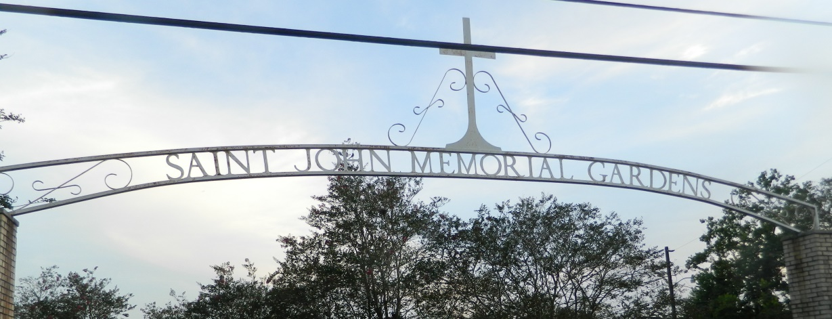

Donnie Johnson , entered into eternal rest on Wednesday, August 22, 2018 at the age of 67. Donnie was loved by all who knew him. A loving husband, father and grandfather. Donnie is survived by his wife of 46 years Myra W. Johnson.2 children, Jonathan and Jauwana Johnson. 7 siblings, 6 grandchildren and 1 great grandchild.

Funeral services are scheduled for Saturday, Sepember 1, 2018 at 11:00am from First Community Antioch Baptist Church, 10860 Hwy. 3125 Lutcher, La.70071, Pastor Ferdinand Gaines, Jr. officiant. Visitation at the church at 10:00am until service begins. Entombment St. John Memorial Garden, Airline Hwy, LaPlace, La. Final care entrusted to Treasures of Life Funeral Services, 315 E. Airline Hwy., Gramercy, La.

<http://www.treasurefunerals.com/> (accessed 10/5/2018)