Elizabeth (Sterling) Johnson
September 26, 1950 – March 1, 2005
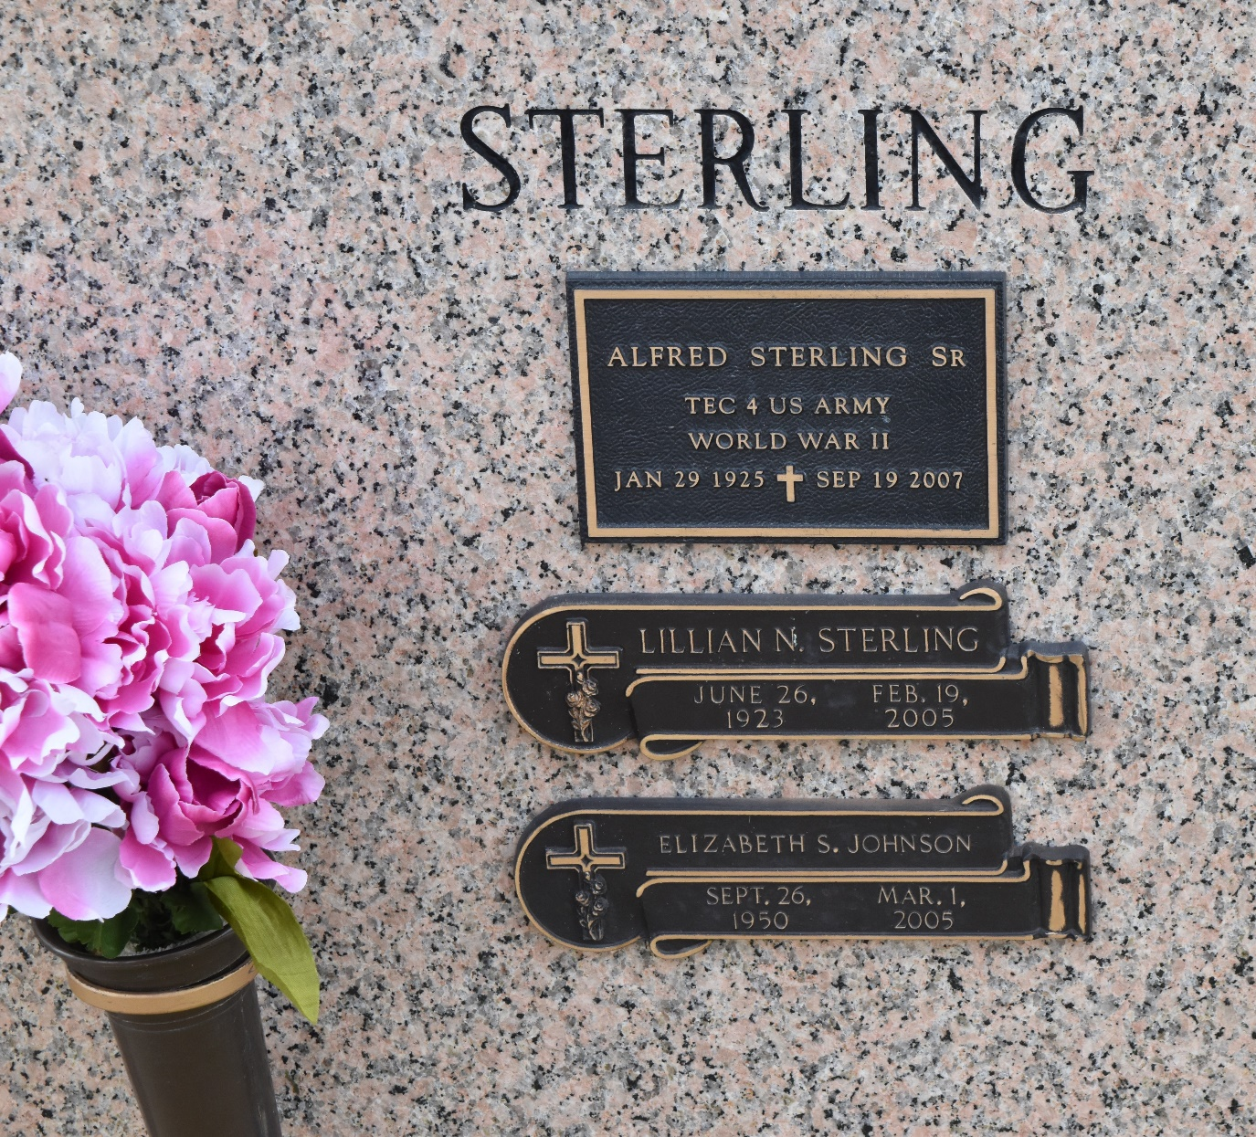

Elizabeth Sterling Johnson Of Garyville, La On Tuesday, March 1,2005. At St. James Hospital, Lutcher, La. Beloved Wife Of J.W. Johnson. Daughter Of Alfred Sterling, Sr. And The Late Lillian Noel Sterling. Beloved Mother Of Tennia (Sylvester) Williams And Jason Stevenson. Stepmother Of Jayson Bardell. Sister Of Donald (Mona) Noel Sr., Harold Sterling Sr., Clara Radcliff, Peggy Bradford, Deborah (Cecil) Martin, Alfred (Kay) Sterling Jr. And Joann Levi. Grandmother Of Sylvester Williams, Jr. Also Survived By (7) God- children, A Host Of Nieces, Nephews, Aunts, Uncles, Sisters And Brothers-In-Law, Cousins And Friends. A Native And Resident Of Garyville, La. Age 54 Years.
Relatives And Friends Of The Family, Also Pastor, Officers And Members Of The New Home Ministries, Neighboring Churches. Employees Of St. John Parish Clerk Of Court Office And St. John Sheriff Office Are Invited To Attend A Celebration On Life Service On Friday March 4, 2005 At 11:00 A.M. From The New Home Ministries, 612 Main St. Laplace, La. Pastor Steve O. Allen, Sr. Officiating. Entombment St. John Memorial Gardens Mausoleum, Laplace, La. Visitation On Thursday, March 3, 2005 From 5:00 P.M. Until 8:00 P.M. At The Baloney Funeral Home, 399 Earl Baloney Dr. Garyville, La And After 9:00 A.M. On Friday At The Church. The Baloney Funeral Home, 399 Earl Baloney Dr., Garyville, La 70051 985-535-2540 In Charge Of Arrangements.

Times Picayune, New Orleans, Louisiana
March 3, 2005

