J. W. Johnson
February 20, 1946 – April 18, 2020

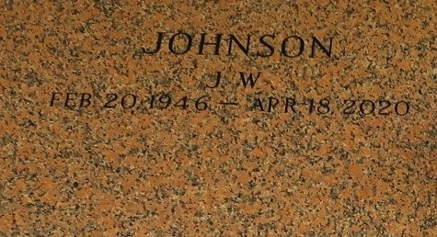

J. W. Johnson, Jr., a resident of St. John Parish, departed this life on Saturday, April 18, 2020, at Ochsner Hospital in Jefferson, LA, at the age of 74. During his youth, he was the renowned, respected entrepreneur of Pied Piper's/Survivor's Lounge in Reserve, LA. JW was a proud retired Law Enforcement Officer with St. John Sheriff Department. He was a dedicated member of First Community Antioch Baptist Church in Gramercy, LA, the late Reverend Ferdinand Gaines.
Those cherishing his memory are his loving wife Sylvia Brown Johnson, his loving children Jayson Bardell, (Treniece), Cabrini (Shawn) Shahzad, Valdais (Sharon) Scott, and Thaddeus Scott; his siblings, Charles Johnson Sr., (Phyllis), Earnestine Joseph, Shelia Williams, and Sandra Jackson, (Willie), his sisters and brothers-in-law, Randall (Joyce) Brown, Lionel (Leshia) Brown, Blanch Fernandez, and Ernie Williams; devoted godchildren Theresa Green and Dionne Cook; 10 grandchildren, 2 great-grandchildren, and a multitude of devoted nieces and nephews who adored being in his presence, enjoying endless humor and benefitting from life taught lessons; cousins and other relatives and friends.
He was preceded in death by his parents JW Sr. and Lubertha Johnson, his sisters Lillie Hugh, and Izola Johnson, his in-laws Robert Williams, Deforest Brown, Theresa Williams, Roy Brown, and Reno and Ethel Brown.
A private burial will be held at St. John's Memorial Gardens on Wednesday, April 22, at 11 a.m. Bardell's Mortuary of Mt. Airy, LA in charge. Information: (985)535-6837.

Published in The Times-Picayune from Apr. 21 to Apr. 22, 2020.

