June Renee (Gross) Johnson

June 18, 1965 – May 13, 2013

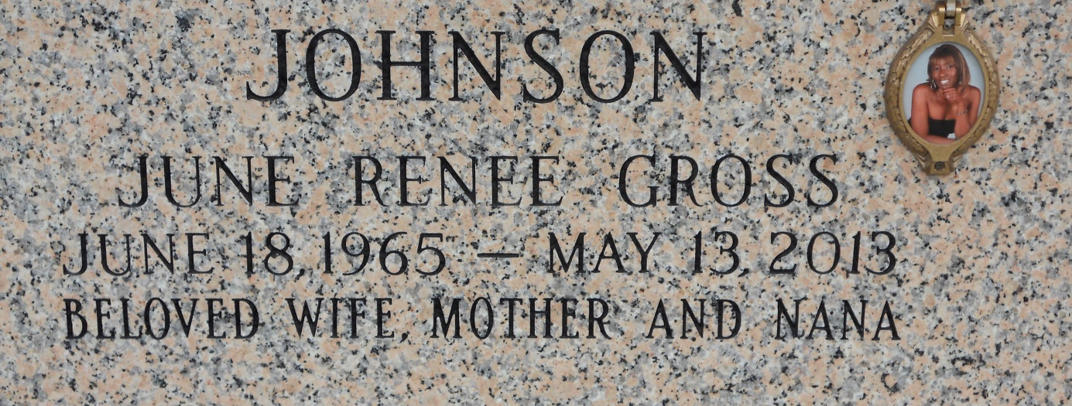

Photo by Team T Lo

June Renee Gross Johnson, 47, passed away in peace, surrounded by love on May 13, 2013.   
 A lifelong resident of Montz, LA, June attended Destrehan High School and was an employee of the St. Charles Parish Public School System. June was a member of Providence Baptist Church No. 2 where she formerly served as an usher.   
 Greeting her with open arms as she arrived to Heaven's pearly gates were her parents, Dolores Scott Gross and Harold Taylor; a brother, Roland Lewis; her grandparents, Mary and Royal Scott; her aunt Wilhelmina Scott Smith; and her nephew, Raydell Brumfield.   
 June leaves to cherish and honor her memory her husband, Kevin Johnson; her children, Trenya Gross Scott (Patrick), DeRoy Gross (Ashley), and Lark Gross; her siblings, Mary R. Taylor, Priscilla Hawkins (Warren), Terry Gross, and Penny Hollins; her aunt Carrie Scott Augillard (Leo); her mother-in-law, Lee Ester Johnson; 11 grandchildren; 5 sisters-in-law; and a host of nieces, nephews, family, and friends.   
 Visitation will be held Saturday, May 18, 2013 at 9 a.m. at Providence Baptist Church No. 2, 152 Union Lane, Montz, LA. A Home Going Celebration will follow at 10 a.m. The Rev. Donald Brown will officiate. A Christian burial will follow at St. John Memorial Gardens, 2205 W. Airline Hwy., LaPlace, LA. Robottom Mortuary is in charge of arrangements.  
  
**Published in The Times-Picayune (LA) from May 15 to May 17, 2013**