Oscar Ignatius Johnson III

July 1, 1983 – June 19, 2005

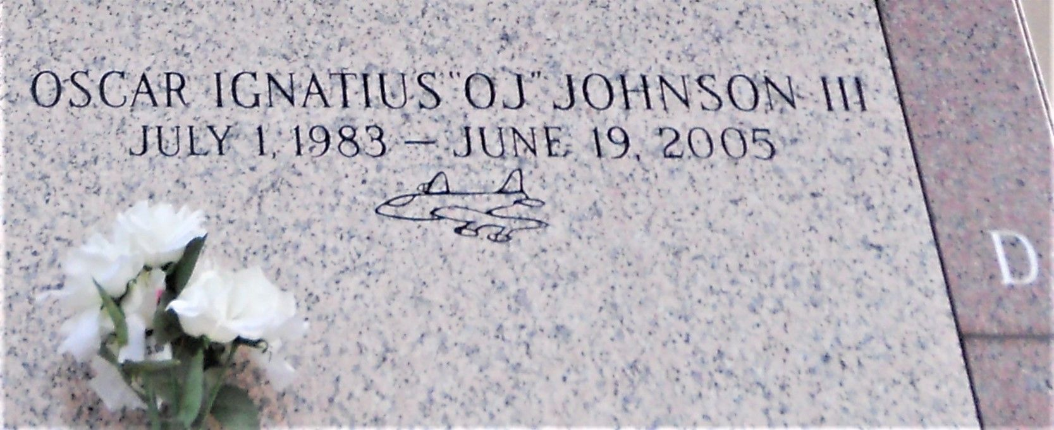

Photo by Team T Lo

Oscar Ignatius 'O.J.' Johnson III, A Photo Tech At Wal-Mart Super Center In Laplace, La At His Residence On Sunday, June 19, 2005. Beloved Son Of Vaneesa Linton And The Late Oscar Johnson, Jr. Brother Of Arianna Runner, Bridgett And Tameka Johnson. Grandson Of Earl And Betty Linton, And The Late Oscar And Leona Johnson. Devoted Nephew Of Yasmin Linton. Also Survived By A Host Of Aunts, Uncles, Cousins And Friends.

A Native & Resident Of Reserve, La. Age 21 Years.

Relatives And Friends Of The Family, Also Priest And Parishioners Of Our Lady Of Grace Catholic Church, Reserve, La. Employees of Wal-Mart, Perino's Nursery, Boes Corp. Boes Iron Works, East St. John High School Class Of 2001, Are Invited To Attend A Mass Of Christian Burial On Saturday, June 25, 2005 At 11:00 A.M. Form Our Lady Of Grace Catholic Church, Hwy 44, Reserve, La. Father Jospeh Rodney, Celebrant. Entombment St. John Memorial Gardens Mausoleum, Laplace, La. Visitation On Friday, June 24, 2005 From 5p.M. - 8p.M. From The Baloney Funeral Home, 399 Earl Baloney Drive, Garyville, La And Saturday, After 9:00 A.M. At The Church. Recitation Of The Rosary At 10:15 A.M. The Baloney Funeral Home, 399 Earl Baloney Drive, Garyville, La 70051 (985) 535-2540 In Charge Of Arrangements.

**Times Picayune (LA); 06-24-2005**