Penny Marie (Thomas) Johnson
October 8, 1965 – January 25, 2022

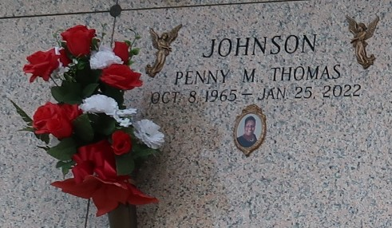

On January 25, 2022, Heaven opened its gates for a true servant to enter the Kingdom and take advantage of the better life. Penny Marie Thomas Johnson, a native of Laplace, LA departed this earth in New Orleans, LA at 56 years of age. Daughter of the late Muriel Chopin Thomas and Preston Thomas Jr., She is survived by her Husband, David Johnson, her son, Solomon Johnson, her siblings Derrick, Dominick, Lynncoy, Randell, Lakwan and Nicole Thomas (Ben). Also, a host of aunts, uncles' nieces, nephews, brother and sisters in law, Women of essence social club, other relatives, and friends.
Funeral Services will be held Saturday, January 5, 2022 at New Wine Christian church, 1929 W. airline Hwy. Laplace, LA beginning at 9:30 a.m. Viewing will begin at 8 a.m., Rev. Freddie Howard Officiating. Interment in St. John Memorial Gardens. Laplace, LA. Due to CDC (Covid19) restrictions seating may be limited, mask and social distancing are required. Professional Services entrusted to the Caring Staff of Hobson Brown Funeral Home. 134 Daisy St. Garyville, La 70051. 985-535-2516.
The Times-Picayune (New Orleans, LA) - Feb. 3 to Feb. 5, 2022

