Raymond Johnson
October 26, 1943 – October 12, 2021

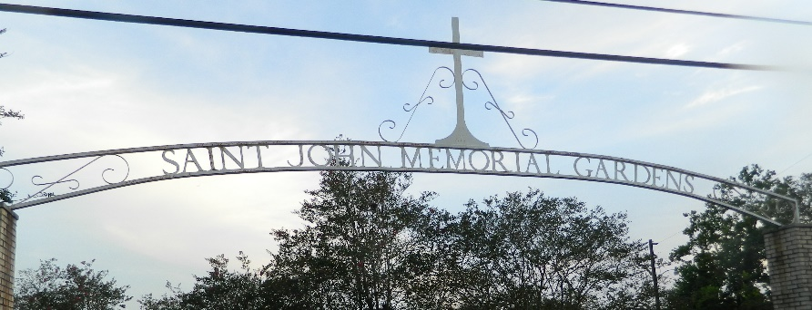

Raymond Johnson departed this life on Tuesday, October 12, 2021. Son of the late Lillian and Ellis Zeno Sr. Raymond is survived by a host of siblings, other relatives, and friends.
Graveside service will be held on Wednesday, October 20, 2021 at St. John Memorial Gardens, 2205 W. Airline Hwy., LaPlace, LA 70068 at 10:00 am. Visitation at the cemetery at 9:00 am. Rev. Willie Smith officiating. Professional services entrusted to the caring staff of Hobson Brown Funeral Home, 134 Daisy St., Garyville, La 70051, 985-535-2516.

Times-Picayune, New Orleans, Louisiana
Oct. 19 to Oct. 20, 2021

