Sedric Thomas Johnson

March 15, 1971 – July 7, 2015

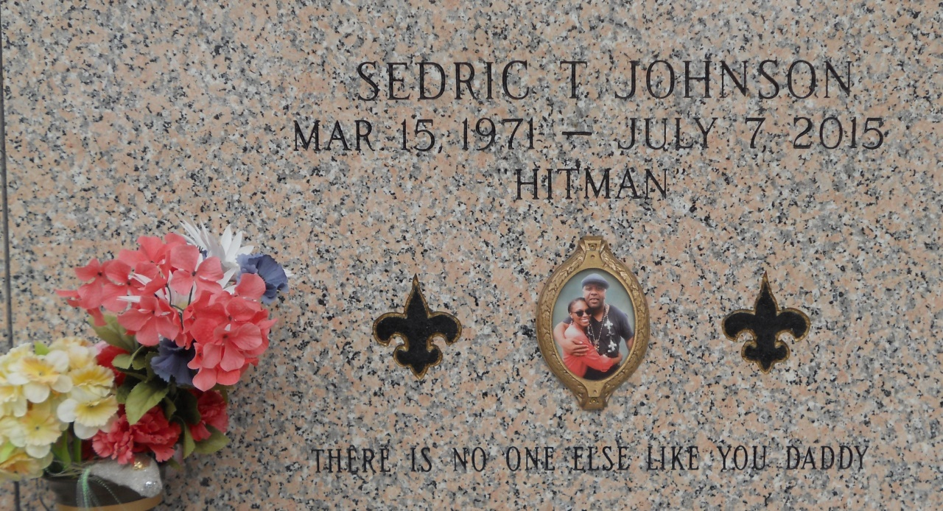

Photo by Team T Lo

Sedric Thomas Johnson, 44 of Laplace, La departed this earthly life on Tuesday, July 7, 2015. Sedric was employed with Savage Services of Laplace, La. He was the co-owner of Southern Outlawz Muzik, LLC and co-owner of Da Sound Booth Studio, LLC of Laplace, La. Son to the late Ruby Johnson and Samuel Scales. Father of A'Nyjah Shaunte' Johnson, who was the apple of his eyes. Fiancé of Gaidrelle Chambelain. Brother of Telly and Natalie Ambrose of New Orleans, La. Also survived by a host of nieces, nephews, cousins, other relatives and friends.  
  
Funeral services will be held at La Belle Place, 1905 W. Airline Highway, Laplace, La. 70068 on Saturday, July 18, 2015 for 11:00 a.m. Visitation will be from 9:00 a.m. until time of service. Interment will be at St. Johns Memorial Gardens Cemetery, Laplace, La. Bishop Ronald Frank will be officiating. Care of my father was entrusted only to the professionalism of The Baloney Funeral Home, LLC, 1905 W. Airline Highway, Laplace, La., 985-224-8460. Condolences can be expressed at [www.baloneyfuneralhome.com](http://www.baloneyfuneralhome.com).

Times-Picayune, The (New Orleans, LA) - Friday, July 17, 2015

Contributed by Jane Edson