Anne Dell (Stockton) Johnston
December 23, 1923 – May 8, 1999

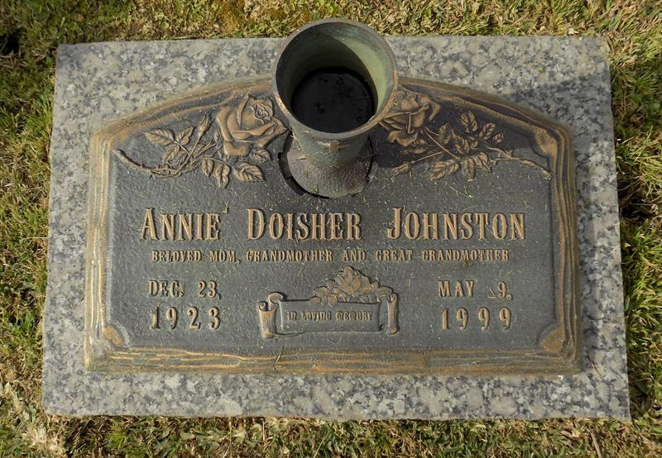

Anne Johnston, A Retired Employee Of Mckenzie's Pastry Shoppe In Laplace, Died Sunday In A Bus Accident In New Orleans. She Was 75. Mrs. Johnston Was Born In Texas And Lived In Laplace For The Past 40 Years. Survivors Include Three Sons, Carl, Ed And Jimmie Doisher; Two Stepdaughters, Deborah Johnston And Linda Saber; Six Grandchildren; And Four Great-Grandchildren.
A Wake Will Be Held Today At 5 P.M. At Millet-Guidry Funeral Home On Airline Highway In Reserve. A Funeral Will Be Held Friday At 10 A.M. At The Funeral Home. Visitation Friday Will Begin At 8 A.M. Burial Will Be In St. John Memorial Cemetery.
Times Picayune, New Orleans, LA
May 13, 1999

