Freddie Mae (Alexis) Jones
1943 – June 28, 2023

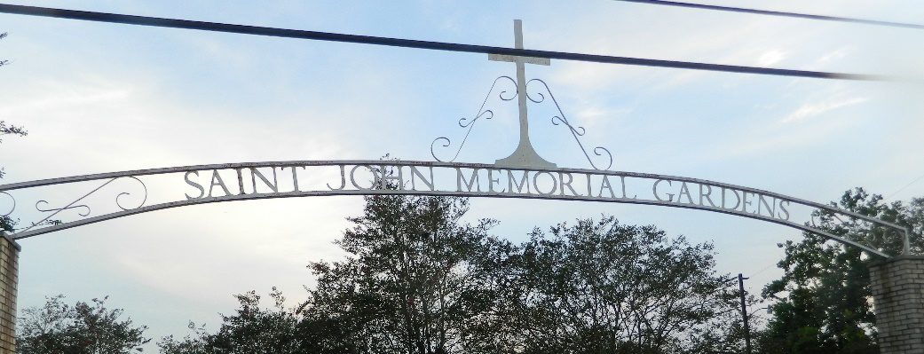

Freddie Mae Alexis Jones, age 79, departed this earthly life and stepped into eternity on Wednesday, June 28, 2023, peacefully at the home of her Godchild, Calette Brown, in Lutcher, LA. Freddie was the daughter of the late George Alexis Sr. and Rebecca Alexis Ellis. She was a native of Mt. Airy and a resident of Inglewood, CA.
Freddie Mae leaves to cherish her memories: siblings, Donell Alexis; Freddrick Alexis, and Troy (Falecia) Campbell; sister-in-law, Audrey Alexis; Godchild and niece, Calette Brown; devoted niece, Lynn Brown; devoted cousin, Terry Albert; Inglewood, CA caregiver, Lynn Poe; and a host of nieces, nephews, cousins, other relatives, and friends. She was preceded in death by her parents, George Alexis Sr., and Rebecca Alexis Ellis; and siblings, George Alexis Jr., Calvin Alexis Sr., and Gloria (Elton) Brown.
Family and friends are invited to the homegoing service on Thursday, July 6, 2023, at 10 a.m. at St. Mark Baptist Church in Mt. Airy, LA. Viewing from 8 am until service time. Interment: St. John Memorial Gardens. Visitation will be held on Wednesday, July 5, 2023, from 3 pm – 6 pm at Bardell's Mortuary, 3856 LA 44, Mt. Airy, LA.
The Times-Picayune, New Orleans, Louisiana
Jul. 4 to Jul. 5, 2023

