Fredna (Cowart) Jones
June 5, 1930 – September 6, 2001

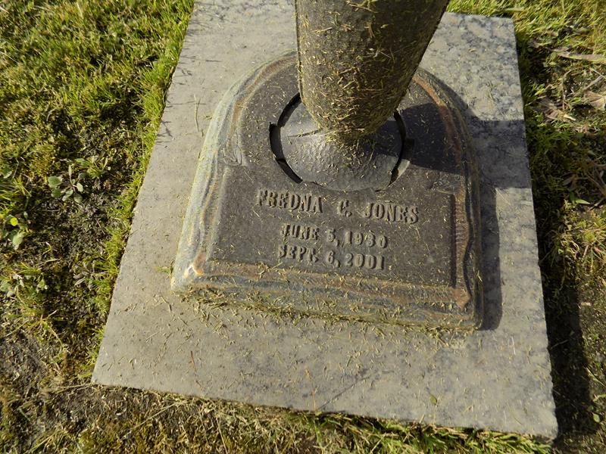

Fredna Cowart Cumbie Jones on Thursday, September 6, 2001 at 7:00 AM. Beloved mother of Tomie F. Cumbie, Georgia Fay Wood, Fredie Kaye Vicknair, Fritz A. Cumbie and the late Karen C. Boe. Also survived by numerous grandchildren and great-grandchildren. Age 71 years. A native of Green County, MS and a resident of Mt. Airy, LA for the past 29 years.
Private services will be held at a later date. In lieu of flowers donations to: The Cancer Association - 824 Elmwood Park Blvd., Suite 240, New Orleans, LA 70123; Ph: 1-800-624 – 2039
Times-Picayune, The (New Orleans, LA) - Friday, January 11, 2008
Contributed by Jane Edson

