Jennifer Ann Jones
October 14, 1966 – December 16, 2020

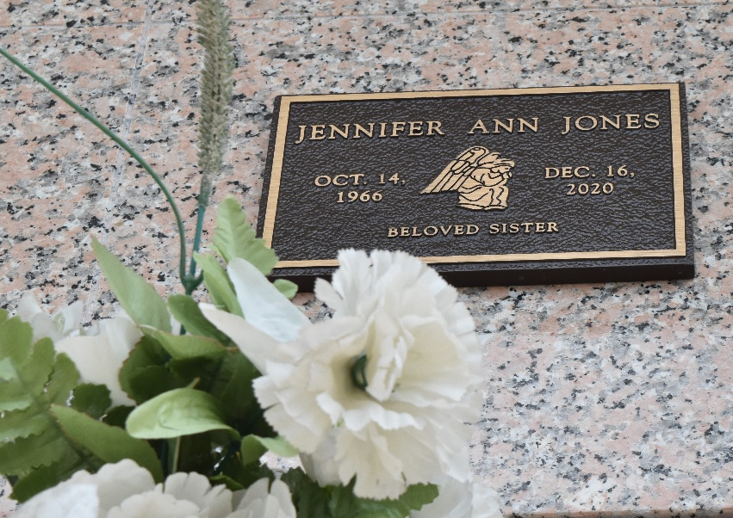

Jennifer Jones departed this life on Wednesday, December 20, 2020. She is survived by a host of family and friends.

Memorial service will be on Saturday, April 24, 2021 at 10:00 am - 10:30 (only) at St. John Memorial Cemetery Laplace, La. Bishop Ronald Frank officiating. Due to CDC (COVID-19) restrictions, seating is limited. Masks and social distancing are required. Professional services entrusted to the caring staff of Hobson Brown Funeral Home, 134 Daisy St., Garyville, La. 70051, 985-535-2516.
The Times-Picayune (New Orleans, Louisiana)
Apr. 22 to Apr. 24, 2021.

