Lawrence Anthony Jones Sr.

July 24, 1952 – October 27, 2014

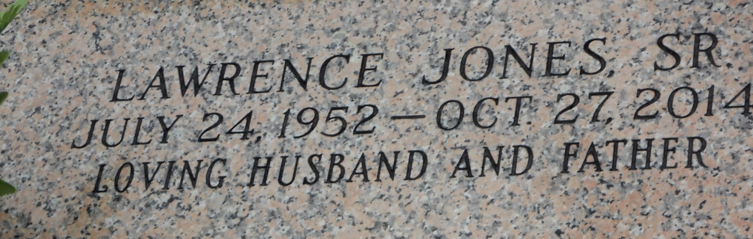

Photo by Team T Lo

Lawrence Anthony Jones Sr., age 62 years, departed this earthly life on Monday October 27, 2014. Beloved Husband of Galyn Simmons Jones for 14 years. Loving father of Jacquetta Jones (Jerry) Gayden, Lawrence Jones Jr., Brandon Eugene and Joshua Jones. Grandfather of Jayce and Jayde Gayden. Brother of Rose J. (Raymond) Johnson, Shirley and Thelma Jones and the late Johnny and Dorothy Jones. Son of the late Charles and Blanche Simpson Jones. Also survived by a host of nieces, nephews other relatives and friends. A native of Reserve, La. and a resident of LaPlace, La.  
 Family and friends of the family also Pastors, Officers and Members of My Heart To Yours FWG, Employees of Cospolich Refrigeration, Ochsner Health System, Campus Federal Credit Union and all neighboring churches are invited to attend the home going celebration on Saturday November 1, 2014 at 10:00 am at From My Heart To Yours F.W.C. located at 119 West Fifth St. LaPlace, La. Pastor Carla Ceasar officiating. Visitation at the above name church from 8:00 am until service time. Interment in St. John Memorial Garden of LaPlace, La.  
 Bardell's Mortuary of Mt. Airy, La. in charge. Information: 985-535-6837

Times-Picayune, The (New Orleans, LA) - Friday, October 31, 2014

Contributed by Jane Edson