Robert George Jones
November 10, 1961 – July 20, 2022

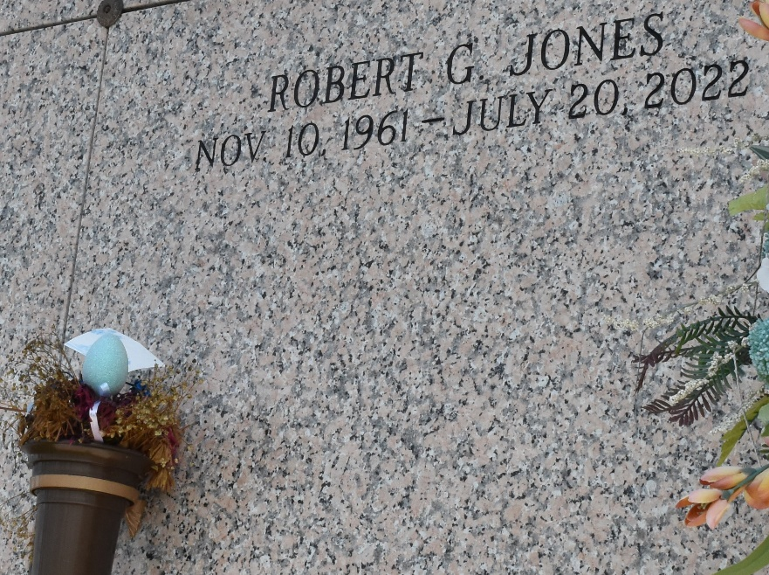

Robert “Robbie” George Jones was born on November 10, 1961 in New Orleans, LA to the late Dorothy “Cat” Jones. Robbie cultivated a love for God at an early age, accepting Him as his Lord and Savior, serving faithfully at Our Lady of Grace Catholic Church in Reserve, LA. He continued his Christian walk when moving to Kenner, LA. He was a faithful member of the New Mt. Bethel Baptist Church under the leadership of Pastor Matthews. Robbie was educated in the St. John School System, where he enjoyed playing bass drum in the band. He will be remembered for his infectious laugh. Robert met the love of his life, Wanda Carter in 1982. They united in Holy Matrimony on June 23, 1983, to that union three daughters were born: Marquita, Latoya, and Robyn Gayla Jones. On Wednesday, July 20, 2022 at his home in Kenner, LA, surrounded by his loved ones, God the Master mind decided his child needed rest and called him home.
He was the loving husband of Wanda Carter Jones, father of NaQuissa Winins (Melvin) of New Orleans, LA, Marquita, Latoya and Robyn Gayla Jones of Kenner, La., sister Delores Jones of St. Rose, LA, half-sister Tammy Valentine, half-brothers: Tony Valentine, Bryan Millet, Gregory Mizell, grandchildren: Devin Hurst, Dameon Earls, Jr., Henry and Clinton Winins, Nicholas Robinson, Jr., Donte’ McGee, Mihayla and Londyn Jones and Noah Tapps, his devoted Aunt/God-Mother Dolores “Cinderella” Collins, Beatrice Jones and Ruby Hall, Laney Thomas and Marietta “Mommie” Thomas, sisters-in-laws: Angela Robinson, Doris Clark, Kendra Toney, brothers-in-law: Lynn, Elias, Anthony and Sean Carter, Jeffery Onyleali, Ronald Robinson, Charles Clark, and Darryl Toney, devoted cousin/spiritual Mother Sylvia and Robert Taylor, Sr., god-son Joseph Jones, Jr., god-father David Cook, Sr., devoted friends: Gail and Curtis Mazique, Gussie Preston, Robert Smith, Nicholas Robertson, Sr., Michael Dennis, Cammie Matthews, Charles Henderson, Charlie Clark, Ryan Robinson, Clarence and David “Pee Wee” Foster, The New Mt. Bethel Church family, a host of nieces, nephew, cousins and friends.
He was preceded in death by his mother Dorothy “Cat” Jones, brother Jeffery Jones, Sr., grandmother Josephine Jones and Grandfather Joseph Jones, nephew Travis Jones, cousin Parnell Collins, mother-in-law Mildred Carter, Father-in-law Elias Carter, Sr, Sister-in-law Karen Onyeali, aunts: Sandra Jones, Ora Lee Ellis, Evelina Melancon, uncles: Joseph Jones, Jr., and Paul Jones, Sr., Alvin, Ben, and Albert Thomas.
Relatives and friends of the family, Pastors, Officers and Members of New Mount Bethel Baptist Church and all neighboring churches are invited to the Celebration of Life, Saturday, August 6, 2022, 11:00 am at New Mount Bethel Baptist Church, 1442 31st Street, Kenner, LA 70065. Rev. Frederick Matthews, Senior Pastor-Officiant. In accordance with the CDC guidelines for COVID-19 mask are suggested for all in attendance. Visitation 10:00 am at the above-named church until time of service. Interment St. John Memorial Gardens, 2205 W. Airline Hwy, LaPlace, LA 70068. There will also be a public walk-through visitation on Friday, August 5, 2022 from 4:00 to 6:00 pm at the Patrick H. Sanders Funeral Home, 605 Main Street, LaPlace, LA. 70068. For Information 985-359-1919. Final Arrangements entrusted to Patrick H. Sanders Funeral Home & Funeral Directors, Inc. 605 Main Street, LaPlace, LA.
The Patrick H. Sanders Funeral Home, LaPlace, Louisiana

