Warren Jones
1949 – November 18, 2018
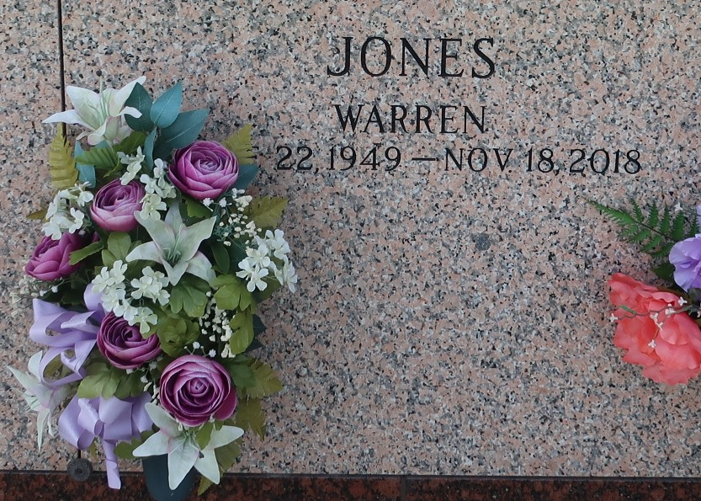

Warren Jones entered into eternal rest on Sunday November 18, 2018 at the age of 76. Husband of Bernadine Perrilloux Jones, Warren leaves to cherish his memories children, grandchildren, siblings, and a host of other relatives and friends.
Relatives and friends are invited to attend the homegoing celebration on Saturday December 01, 2018 at 11:00 a.m. at Beech Grove Baptist Church, 117 Beech Grove Dr., Reserve, La. Visitation at 10am until service time. Rev. Corey Batiste Officiating. St. John Memorial Gardens Laplace, LA. Professional Services entrusted to the caring staff of Hobson Brown Funeral Home, 134 Daisy St., Garyville, La 70051. 985-535-2516

TheNewOrleansAdvocate.com - Nov. 29 to Dec. 1, 2018
Contributed by Jane Edson

