Wilson Jones Jr.
June 10, 1945 – October 21, 2021

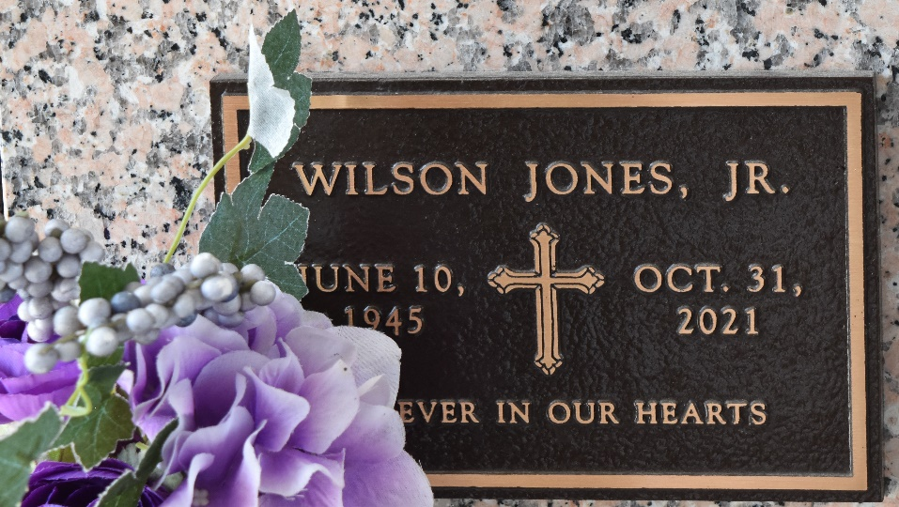

Wilson Jones, Jr. transitioned on Sunday, October 31, 2021 at his nephew’s home in Reserve, LA. Son of the late Josephine and Wilson Jones, Sr. Husband of Emily L. Jones. Father of Michele Joseph (Karl), Wilson Jones, III, Anya Buffer (Chris), Juvona "Cookie" Jones and Vance Jones (Erin). Brother of Stella Mae Johnson, Rita Mae Johnson, Theresa Hornsby (the late Roger), Larry Jones, Sr. (Paula Mae), the late Annie Jones Butler, Elmira Batiste and Warren "Boyee" Jones (Bernadine - living). Also survived by 16 grandchildren, 8 great grandchildren and a host of nieces, nephews, cousins, other relatives and friends. Age 76 years. A native of Reserve, LA and a resident of LaPlace, LA.
Relatives and friends of the family also pastors, officers and members of Beech Grove Baptist Church and all neighboring churches are invited to attend a Memorial Service at Beech Grove Baptist Church, 117 Beech Grove Drive, Reserve, LA on Saturday, November 6, 2021 at 11:00 am. Rev. Cory Batiste, Pastor, officiating. Visitation with the family from 10:00 am until Service Time. Interment will be private. In lieu of flowers, please donate to St. Jude Children's Research Hospital (www.stjude.org) or Gastric Cancer Foundation (www.gastriccancer.org) in the name of Wilson Jones, Jr. Due to COVID-19, everyone in attendance must wear a mask and practice social distancing. Service by Robottom.

The Times-Picayune, New Orleans, Louisiana
Nov. 4 to Nov. 6, 2021

