Billy Joseph
July 13, 1959 – October 7, 2021

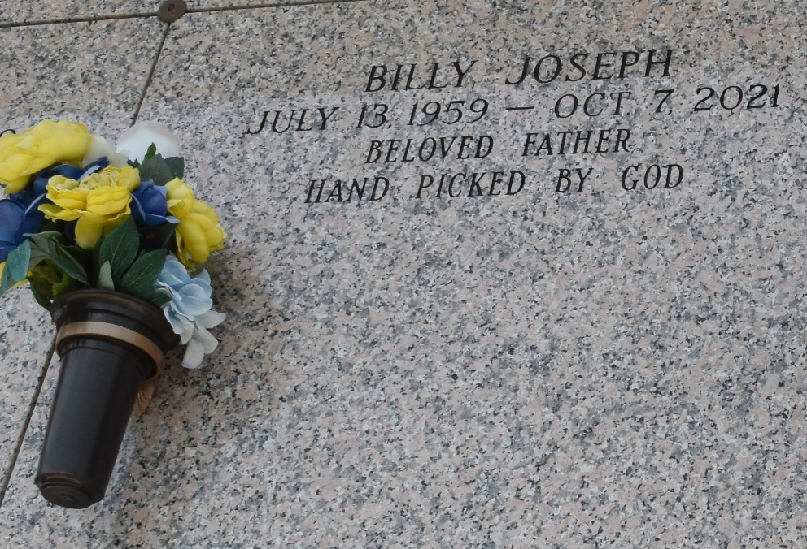

Billy Joseph departed this life on Thursday, October 7, 2021. Son of the late Leola and Andrew Joseph Sr. Father of Shandrika (Efrem) Gordon and the late Danielle Jones. Stepfather of Keviona Jones. Brother of Dolores (Ernest Sr.) Florian, Ernestine (Calvin Sr.) Hewitt, Willie (Sharon) Joseph, and the late Brenda Mitchell, Michael, and Andrew Joseph Sr. Survived by grandchildren, great-grandchildren, nieces, nephews, other relatives, and friends.
Celebration service will be held on Friday, October 22, 2021 at 11:00 am at the Greater Golden Grove B.C., 127 S. Mulberry St Gramercy, LA 70052. Rev. Emil D. Mitchell officiating. Visitation from 10:00 am until service time. Interment at St John Memorial Gardens, LaPlace, LA. Professional services entrusted to the caring staff of Hobson Brown Funeral Home, 134 Daisy St., Garyville, La 70051, 985-535-2516.
The Times-Picayune (New Orleans, Louisiana)
Oct. 19 to Oct. 22, 2021
Contributed by Jane Edson

