Earnest Joseph Sr.
1937 – May 27, 2015

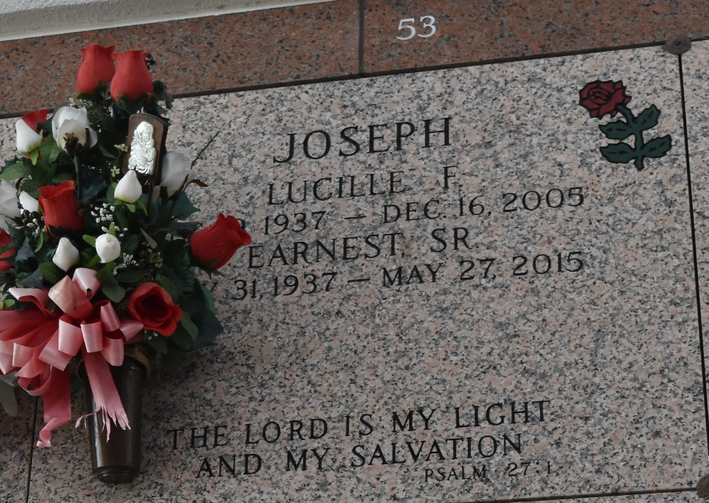

Earnest Joseph Sr. passed away on May 27, 2015. Husband of the late Lucille F. Joseph. Father of Marie L. Snyder, Bernadette Alvis, Dianne Joseph, Wanda Bourgeios, and the late Earnest Joseph Jr. Survived by (17) grandchildren, (45) great grandchildren, and a host of other relatives and friends.
Funeral service on Saturday, June 6, 2015 at 10:00am at Providence B.C. #2, 152 Union Ln, Montz LA 70068, viewing at 9:00am until service time. Rev. Donald Brown, Pastor officiating. Internment St. John Memorial Gardens, Laplace, La. Service Entrusted to Hobson Brown Funeral Home Garyville, La 70051 985-535-2516

The Times-Picayune, New Orleans, Louisiana
Jun. 2 to Jun. 5, 2015

