Gary C. Joseph

May 23, 1984 – April 28, 2013

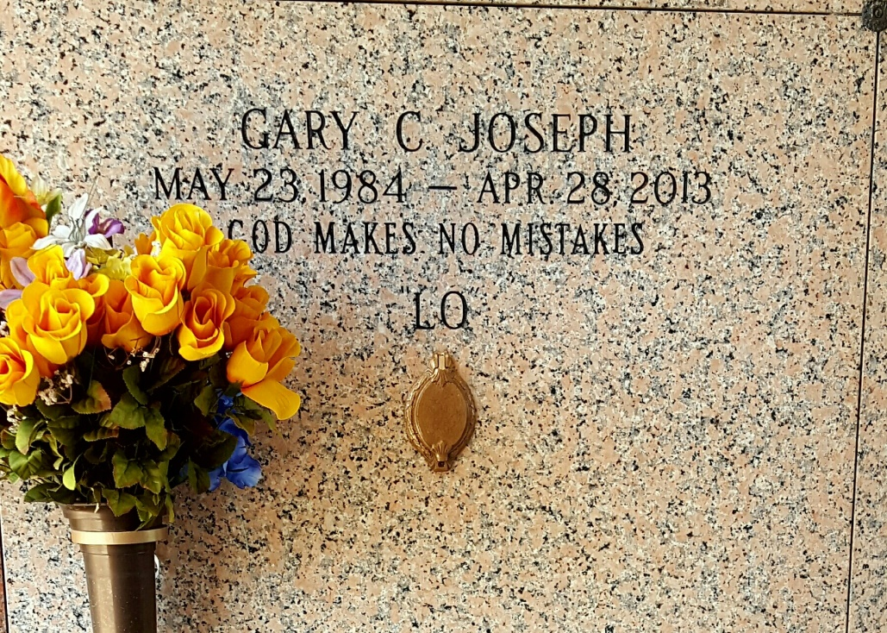

Photo by Team T Lo

LaPlace man, 28, dies in motorcycle crash Sunday

A 28-year-old LaPlace man died Sunday afternoon in a motorcycle crash on Louisiana 3188, State Police said.  
 Gary C. Joseph died in the accident about 1:25 p.m., according to Troop B Public Affairs spokeswoman Melissa Matey. Joseph was immediately taken to River Parishes Hospital where he was pronounced dead.  
 Joseph was driving a 2012 Yamaha RZFR1 motorcycle on Louisiana 3188, heading north in the left lane at a high rate of speed, Matey said. When he failed to negotiate a left curve, he lost control of the motorcycle and veered into the median, striking two road signs, State Police said.  
 The cause of the accident is unknown. Toxicology results are pending an autopsy.

Times-Picayune, The: Web Edition Articles (New Orleans, LA) – Sunday, April 28, 2013

Contributed by Jane Edson