Gladys Mae (Jack) Joseph

August 29, 1934 – September 21, 2014

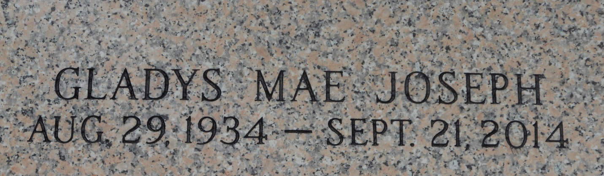

Team T Lo

Gladys Mae Joseph, age 80, departed this life on Sunday, September 21, 2014. Daughter of the late Gustave Jack and Laura B. Howard. Mother Benny, Hilton, Larry and Robert Joseph, Addie Tezeno, Carol Green, Arlene August, and the late Gregory Joseph Sr. Also survived by a host of grandchildren, daughters & sons in law, nieces, nephews, other relatives and friends.  
  
Relatives and friends are invited to attend the Home going Services on Saturday, September 27, 2014 at Mt. Calvary B.C., 127 W. 3rd St., Laplace, La., at 12noon. Rev. Freddie Howard Officiating. Interment in St. John Memorial Gardens. Viewing at 10a.m. until service time.  
  
Service Entrusted to Hobson Brown Funeral Home, Garyville, La, 985-535-2516

Times-Picayune, The (New Orleans, LA) - Friday, September 26, 2014

Contributed by Jane Edson