Homer James Morgan Joseph
January 4, 1947 – December 4, 2006

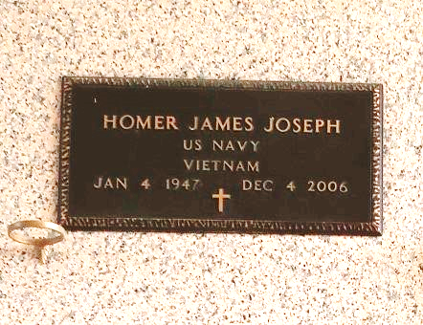

Homer James Morgan Joseph 'Boggie', on Monday, December 4, 2006 departed life at his residence. Beloved father of Nedra Snowden (Timothy), Gonzales, LA, Shannon Joseph, Reserve, LA and Bobby Gibson, Reserve, LA, who he mentored and raised as a son. Grandfather of Jade Frank and Jayce Snowden. Survived by three sisters: Olivia Morris, Dorothy Duhe and Elois Joseph, Reserve, LA. Preceded in death by his father and mother, Fred and Olevia Joseph; and one brother, Junius Noel. Also survived by a host of nieces, nephews and relatives. Relatives and friends of the family, including employees of DuPont, Tri Parish Medicaid, Canon Hospice Care and St. John Community Action Agency are invited to attend the Homegoing Service on Monday, December 11, 2006 at Beechgrove Baptist Church, 117 Beechgrove Drive, Reserve, LA. Visitation starts at 10:00 a.m. followed by service at 12:00 noon. Interment to follow at St. John Memorial Gardens, LaPlace, LA. Arrangements by DESSELLE FUNERAL HOME, Baton Rouge, LA.
The Times-Picayune (New Orleans, Louisiana)
Dec. 10, 2006

