Lucille (Fobb) Joseph
December 19, 1937 – December 16, 2005

2
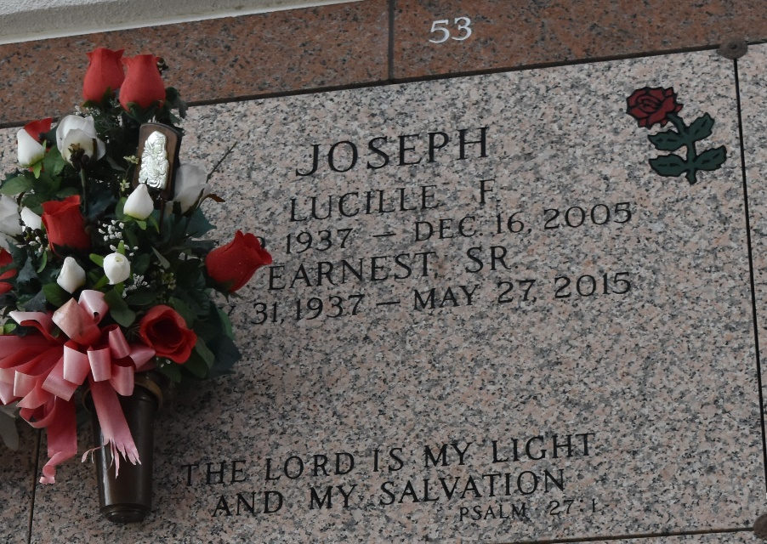

Lucille Joseph Departed This Life On Friday, December 16, 2005 At East Jefferson General Hospital, Metairie, La.
Daughter Of The Late Shelton And Nitsie Fobb. Wife Of Ernest Joseph, Sr. Mother Of Marie Snyder, Bernadette Alvis, Dianne Joseph, Wanda (Wilmer) Bourgeois, And The Late Earnest Joseph, Jr. Sister Of Hefert, Roy, And William Fobb, Bessie Mercier, Hilda Molton, Shirley
Millet, And The Late Herbert And Howard Fobb, Corita Powers, Hazel Wilkens, Gertrude Hamilton, Francis Stokes And Daisy Joseph. Also Survived By (18) Grandchildren, (21) Great Grandchildren, A Host Of Aunts, Uncles, Nieces, Nephews, Cousins, Other Relatives And Friends. A Native And Resident Of Laplace, La. Age 67.
Relatives And Friends Of The Family, Pastor, Officers And Members Of Providence Baptist Church, And All Neighboring Churches Are Invited To Attend The Funeral Service On Thursday, December 22, 2005 At 11:00a.M. At The Above Named Church, 240 Pine St. Laplace, La. Rev. Willie Smith, Pastor, Officiating. Internment In St. John Memorial Garden, Laplace, La. Private Viewing Only. Services Entrusted To Hobson Brown Funeral Home Garyville, La.

Times Picayune, New Orleans, Louisiana
December 21, 2005

