Eugene C. Julien Sr.
July 17, 1984 - October 22, 2020

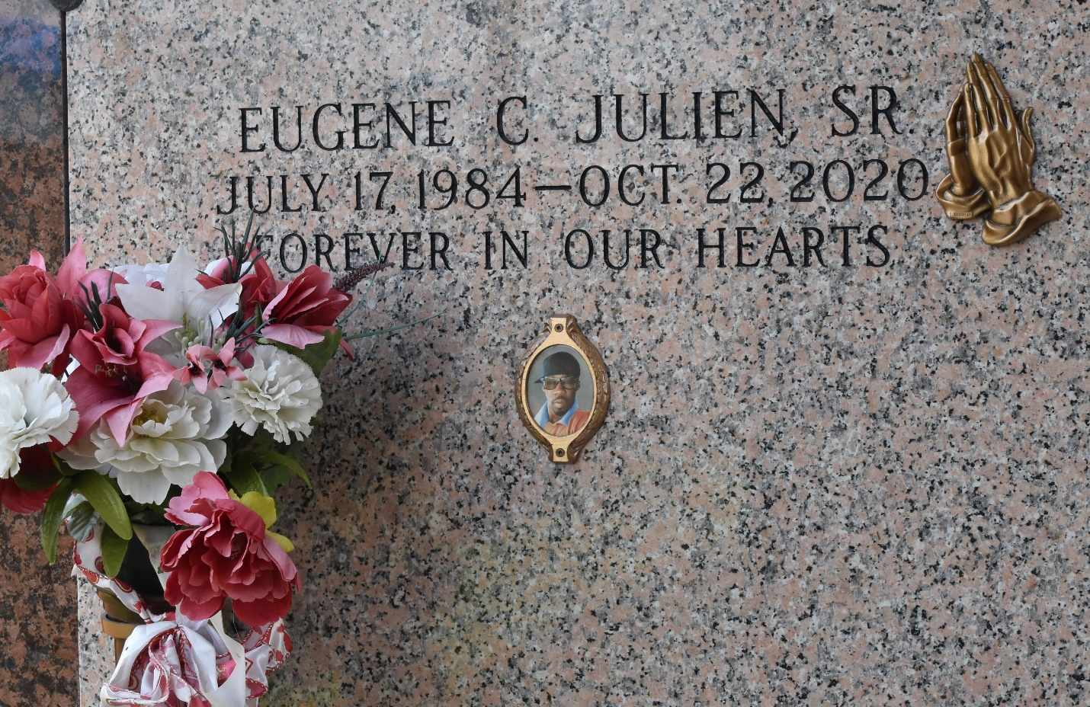

Eugene C. Julien Sr, age 36, departed this life on Thursday, October 22, 2020. Husband of Shiquita D. Julien. Son of Geraldine Weber Julien and Anthony Paul Isom. Father of Eugene and Emon Julien. Brother of Jonathan Julien, Durrell Swafford Jr, Eshonna and Anthony Isom Jr, NaKeisha, Ardean and Anthony Graham. Eugene is survived by his grandparents, sisters-in-law, brother-in-law, nephews, nieces, aunts, uncles, other relatives, and friends.
Celebration service will be held on October 31, 2020 at True Light B. C., 258 S. Little Hope St., Garyville, LA, at 11:00 am. Minister Jerome Weber officiating, viewing on Friday at Hobson Brown Funeral Home from 5-6:30 pm and at the above named church from 9:00 am until service time. Interment at St. John Memorial Garden. Service entrusted to HOBSON BROWN FUNERAL HOME 134 DAISY ST. GARYVILLE, LA. 985-535-2516.
The Times-Picayune (New Orleans, LA)
Oct. 29 to Oct. 31, 2020

