Hazel (Schexnaydre) Keating
January 6, 1926 - December 2, 2005

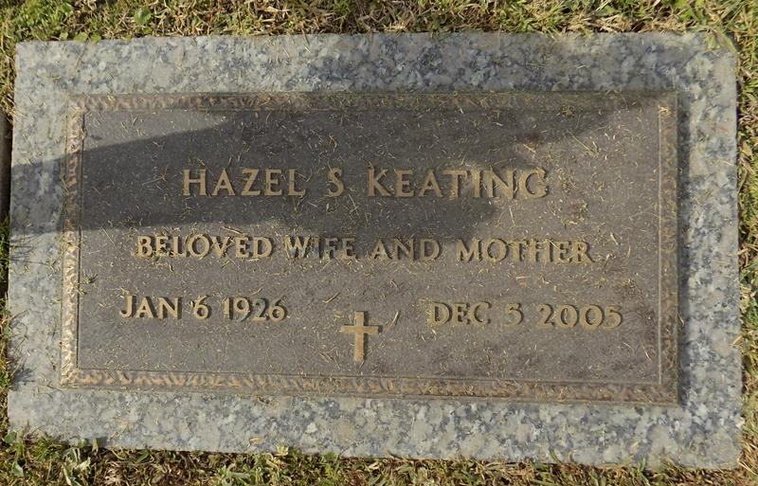

Hazel Schexnaydre Keating, of Panama City, Florida, entered into eternal rest on Monday, December 5, 2005. Beloved wife of the late Henry L. Keating. Mother of the late Cheryll and Glen Keating. She was the daughter of the late Lucien Schexnaydre and Myrtle Troxclair. She was preceded in death by her brothers, Wilbert and Nolan Schexnaydre. She is survived by her stepmother, Maudrie Kearse; brother, Sturgis Schexnaydre; sister, Phyllis Piazza; grandchildren: Kerry, Jessica and Glen Keating, Jr. and his wife Jennifer; and great grandchildren: Gabrielle, Glen III and Chase Keating. She is also survived by many nieces and nephews. A native of New Sarpy, LA and longtime resident of Laplace, Louisiana.
Relatives and friends of the family are invited to attend Committal Services at 1:30 pm on Saturday, March 11, 2006 at St. John Cemetery in Laplace, LA. Interment following.

The Baton Rouge Advocate (LA)
Aug. 14 to Aug. 18, 2017

