Nancy Ann Keating

February 25, 1956 – May 15, 2009

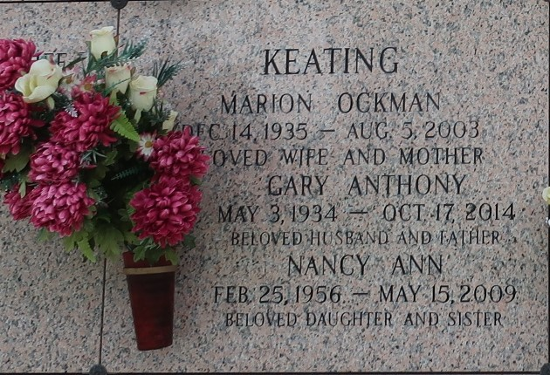

Nancy Keating on Friday, May 15, 2009 at 2:18PM. Beloved daughter of Gary Keating and the late Marion Ockman Keating. Sister of Gary Keating, Jr., Susan Abt, Janet Torres and the late Peggy Mire. Beloved Nanny of Misha, Jamie, Shawn, Tony, Elliot, Darren, Aimee, Holly and Brent. Also survived by great nieces and nephews. Age 53 years. A native of LaPlace, LA and a resident of Reserve, LA.
Relatives and friends are invited to attend services. Visitation at Millet-Guidry Funeral Home, 2806 W. Airline Hwy., LaPlace, La. on Monday, May 18, 2009 from 10:00AM to 12:00 noon. Followed by Religious Services at the Funeral Home Chapel at 12:00 noon. Burial in St. John Memorial Gardens Cemetery, LaPlace, La.
The Times-Picayune, New Orleans, Louisiana
May 17, 2009

