Joanie (Gomez) Keller
January 12, 1965 – January 26, 2011
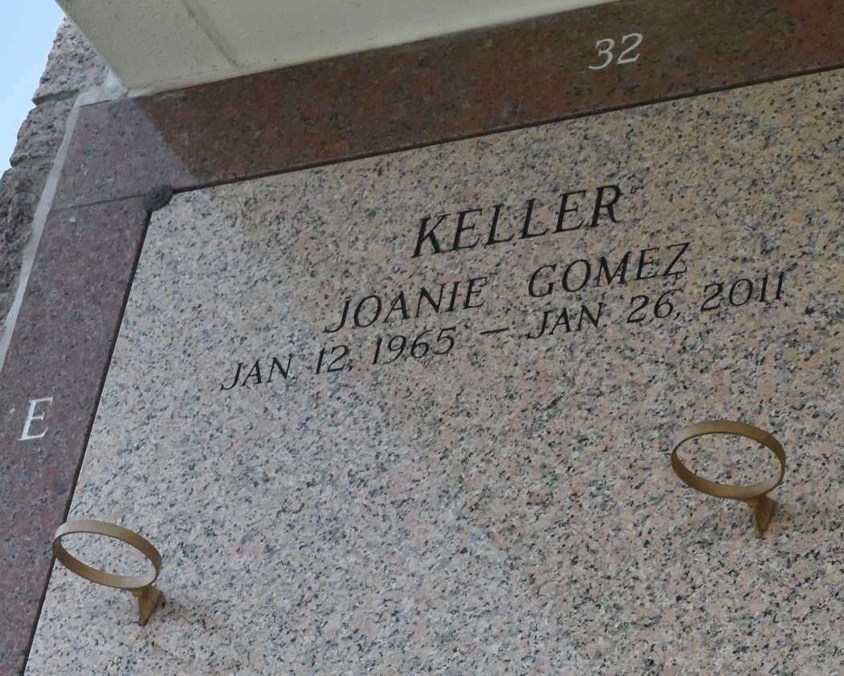

Joanie Gomez Keller, 46, passed away on Wednesday, Jan. 26, 2011.
She was the beloved wife of Roland (R.J.) Keller Jr., mother of Kimberly and Kristen Keller, daughter of the late Raymond and Betty Gomez, daughter-in-law of Alma Keller and the late Roland Keller Sr., sister of Sandi Lambert (Billy) and Raelynne Duhon (George Jr.) and sister-in-law of Rachel Zeringue, Ernest Cambre and Kirk Keller. She is also survived by nieces and nephews.
A resident of LaPlace, she was kind, good-hearted, a generous wife, mother and sister and a friend who was known for her giving personality.
Visitation and services were held at Millet-Guidry Funeral Home in LaPlace on Saturday, Jan. 29, followed by burial in St. John Memorial Gardens Cemetery in LaPlace.
Unknown source

