Karen Keller
April 5, 1969 – June 13, 2021
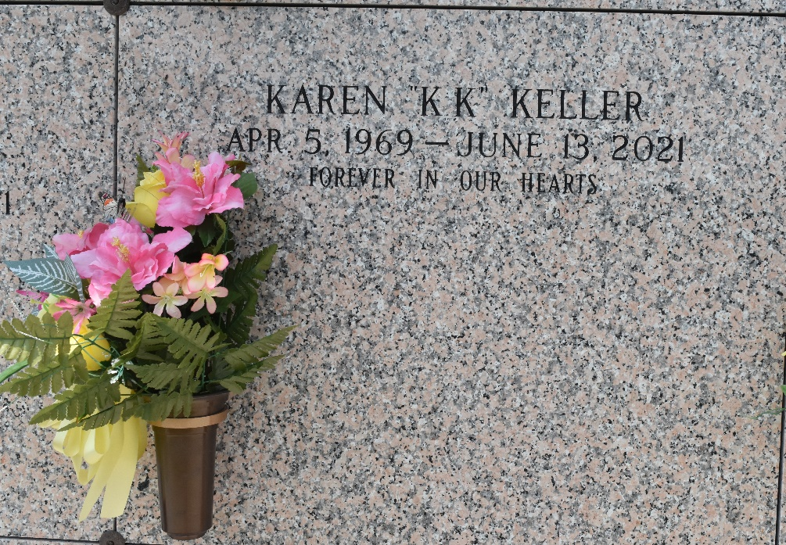
Karen "KK" Keller passed away peacefully at her residence surrounded by family on Sunday, June 13, 2021 at the age of 52. She was born in New Orleans and was a longtime resident of Reserve, LA. Beloved companion of Earl Mayer. Loving mother of Shelby Marino and Hailey Marino. Mimi of Sophia, Kaiden, Kai, Carson and Cayson. Daughter of Eugene J. Keller, Sr. and the late Florence Shipley Keller. Sister of Debra Keller and Eugene J. Keller, Jr. Also survived by her nephew, who was like a baby brother to her, Wyatt Keller; god-daughter, Ashleigh Keller; nieces; nephews; aunts; uncles; and cousins.
Relatives and friends are invited to attend the Visitation and Funeral Service at Millet-Guidry Funeral Home, 2806 W. Airline Hwy., LaPlace on Friday, June 18, 2021. Visitation will be held from 10:00 a.m. to 12:00 p.m. with the Funeral Service to immediately follow at 12:00 p.m. Interment in St. John Memorial Gardens Cemetery, LaPlace, LA.
Millet-Guidry Funeral Home, LaPlace, Louisiana
June 16, 2021

