Donald R. Kimler
August 8, 1920 – January 31, 2005
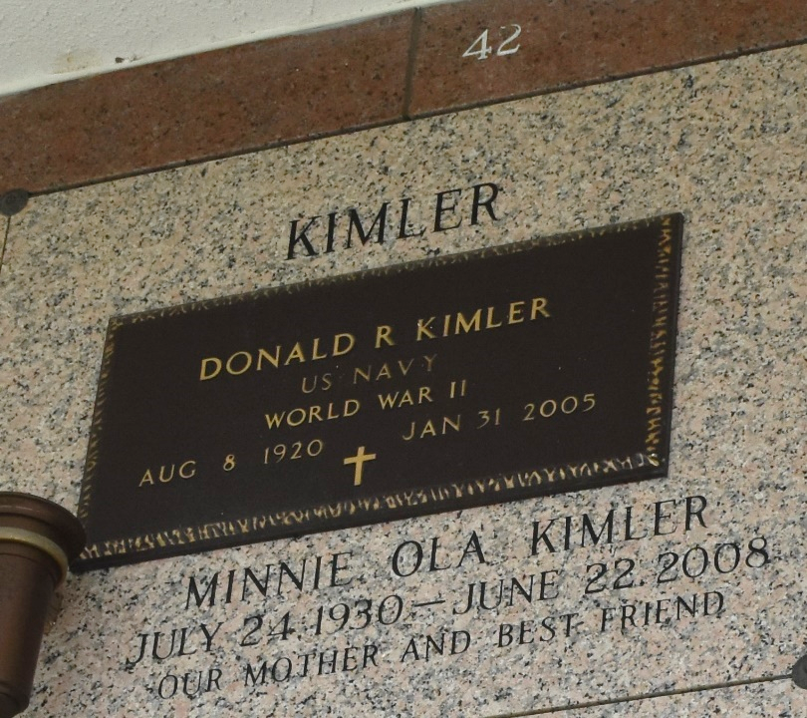

Donald (Don) Kimler On Monday January 31, 2005 At 1:10 Pm. Beloved Husband Of Minnie Kimler. Father And Father-In-Law Of David Kimler, Mary Jane And Sal Giglio, Myrtle And Paul Simoneaux And The Late Patricia Castellaw. Son Of The Late Homer And Stella Kimler. Brother Of The Late James Kimler. Also Survived By 4 Grandchildren, 11 Great- Grandchildren And 2 Great-Great-Grand- Children. He Was A Navy Veteran Of World War II. Age 84. A Native Of Newton, Iowa And A Resident Of Laplace For The Past 30 Years.
Relatives And Friends Of The Family Are Invited To Attend Services. Visitation At Millet-Guidry Funeral, 2806 West Airline Hwy, Laplace On Thursday February 3, 2005 From 10am To 12 Noon, Followed By Religious Services At The Funeral Home Chapel At 12 Noon. Burial In St. John Memorial Gardens, Laplace.
Times Picayune, New Orleans, Louisiana
February 02, 2005

