LaJuanne Marie (Gant) King
April 24, 1984 - March 19, 2024

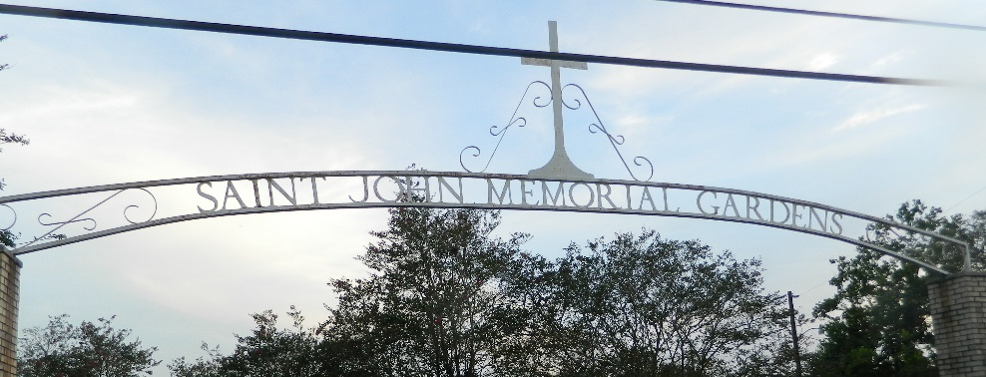

LaJuanne Marie Gant King came into the world on April 24, 1984, born to Isaac "Pete" Gant III and Cassiana P. Gant. She received her education in the St. John the Baptist Parish Public School System and worked at Alamo car rental for 14 years, previously being employed at Humana before her passing. LaJuanne embraced christianity at a young age and later became a dedicated member of New Zion Christian Center in Gramercy, LA, under the guidance of Pastor Emil D. Mitchell. She was known for her strong work ethic and providing for her family with pride. Seeing her daughter and husband happy brought her great joy. LaJuanne enjoyed traveling and looking stylish with her friends Keiosha Scott and Tiffany B. She met her high school sweetheart Kendell King, and they were married on June 9, 2012. They were blessed with 1 daughter, Kenadi King.
LaJuanne is survived by her husband: Kendell King; daughter: Kenadi King; brothers: Isaac Gant IV (Tarika) and Derell Gant (Iesha Triche); niece: Zakiya Brown; nephews: Jayden Payne, Landen Jones, Isaiah McGuffy, and Devante Gant; mother-in-law: Juanita King; father-in-law: Frank Gardner; sister-in-law: Naquisha Anderson; brothers-in-law: Nick King, Thaddeus King, Davon Gardner, and Kenneth King; Godmother: Minister Angel Songy; and numerous aunts, uncles, nieces, nephews, cousins, other relatives, and friends.
She was preceded in death by her parents: Cassiana P. Gant and Isaac "Pete" Gant III; sister: Toccara Payne; grandparents: Isaac Gant, Sr., Gracie Bowser Gant, Ethel Mae Porter, and Viola C. Williams; along with a host of aunts and uncles.
A Celebration of Life honoring LaJuanne Marie Gant King will be held on Saturday, March 30, 2024, at New Zion Christian Center, 216 W. Main St., Gramercy, LA 70052. Visitation beginning at 9AM with services to follow at 11AM. Pastor Emil D. Mitchell, officiant. Entombment to follow at St. John Memorial Gardens, 2205 W. Airline, Laplace, LA 70068.

Treasures of Life Funeral Services, Gramercy, Louisiana
March 29, 2024

