George Godfried Kleinschmidt
October 29, 1926 – April 21, 2004
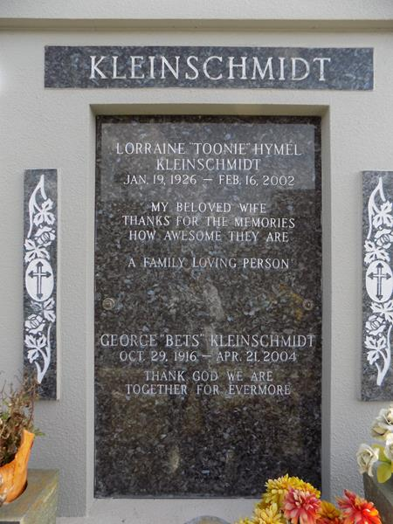
George Godfried Kleinschmidt, a native of New Orleans and a resident of Laplace, Louisiana, for the past 3 years died on Wednesday 21 Apr 2004 at 10:35 p.m. at age 87 years.
He was the husband of the late Lorraine Hymel Kleinschmidt and the son of the late Albert G and Eugenie Wolf Kleinschmidt. He was the brother of the late Charles, Arthur, Albert and C Ernest Kleinschmidt and Elise K Moeller. Also survived by numerous nieces and nephews.
Services were at Millet-Guidry Funeral Home, 2806 W Airline Hwy, LaPlace, on Monday 26 Apr 2004 with interment in St John Memorial Gardens Cemetery, LaPlace.
The Times-Picayune, New Orleans, Louisiana
24 Apr 2004

