Lorraine (Hymel) Kleinschmidt
January 19, 1926 – February 16, 2002
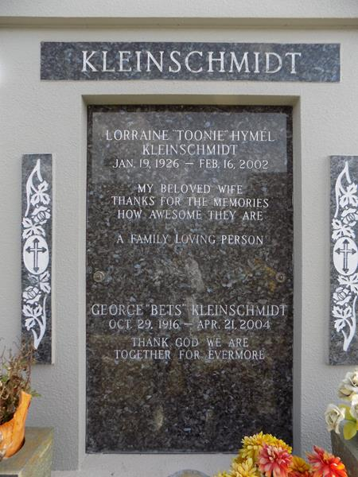
Lorraine Hymel Kleinschmidt, a native of Laplace, Louisiana, a former resident of New Orleans and a resident of Laplace for the past 3 years, died on Saturday 16 Feb 2002 at 1:02 p.m. at age 76 years.
She was the wife of George Kleinschmidt and the daughter of the late Thomassin and Bertha Madere Hymel. She was the sister of Etienette Dufrense, Leona Braud and the late Hilda Nunn, Josephine Brady, Edith Bourgeois, Odette Hymel, France Madere, Paul, Etienne, Lionel and Jules Hymel. Also survived by numerous nieces and nephews.
Funeral services were on Wednesday 20 Feb 2002 at St Joan of Arc Catholic Church, Laplace, with interment in St John Memorial Gardens, Laplace.
The Times-Picayune, New Orleans, Louisiana
20 Feb 2001

