Lois (Billiot) Kliebert

July 5, 1933 – April 26, 2002

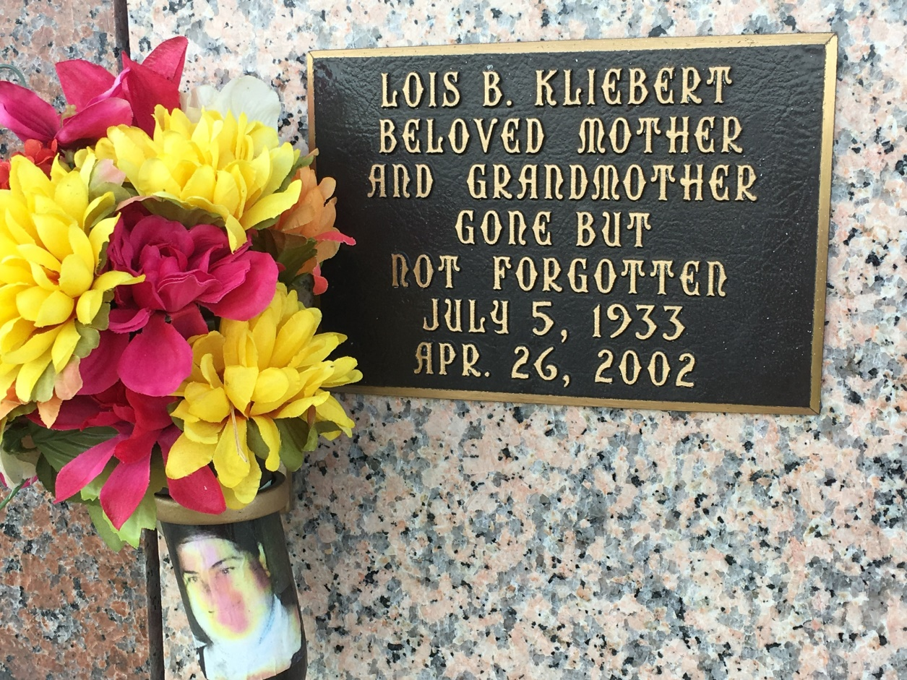

Photo by Team T Lo

LAPLACE - Betty "Lois" Kliebert, 68, a native of Morgan City and resident of LaPlace for the past 25 years, died April 26. She was the wife of the late Eno Kliebert Sr. and mother of Debra LeBlanc, Denise Pitre, Joann Stevenson and Suzanne, Lena, Eno Jr., Kevin, Edwin and the late Diane Kliebert. She was the sister of Maggie Boudreaux and Charles, Cyril and Herbert Billiot. She is also survived by 29 grandchildren and three great-grandchildren.  
  
Services were May 3 in the chapel of Millet-Guidry Funeral Home, LaPlace, with interment at St. John Memorial Gardens, LaPlace.

L'Observateur (La Place, LA) - Monday, May 13, 2002

Contributed by Jane Edson