Charles Thomas Kuhn  
May 14, 1942 - February 29, 2012

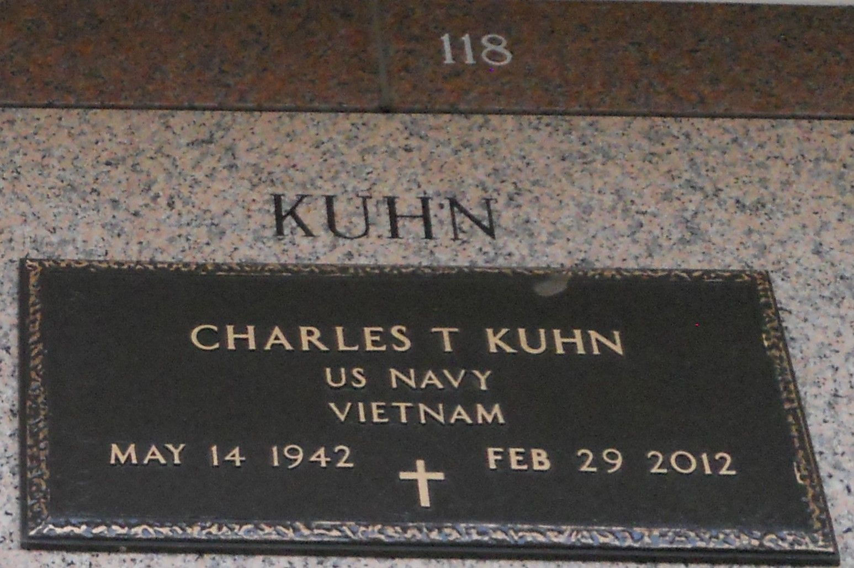

Photo by Team T Lo

Charles Thomas Kuhn, beloved husband, father, grandfather, and great-grandfather. Son of the late Thomas P. Kuhn, Jr. and Lillian B. Kuhn. Husband of Joe Ann Kuhn. Father of Michael C. Kuhn and Scott P. Kuhn. Brother of the late Kenneth H. Kuhn, Alan G. Kuhn and Cheryl K. Davidson. Grandfather of 4 grandchildren and 2 great-grandchildren. Will always be remembered, loved and missed forever.  
  
Viewing will be held on Friday, March 2, 2012 at Millet-Guidry Funeral Home, 2806 W. Airline Hwy., LaPlace, LA from 8:00- 10:00 a.m. with services to follow at St. John Cemetery, LaPlace, LA.

Times-Picayune, The (New Orleans, LA) - Friday, March 2, 2012