Arnold J. Labat

May 24, 1930 - January 8, 2018
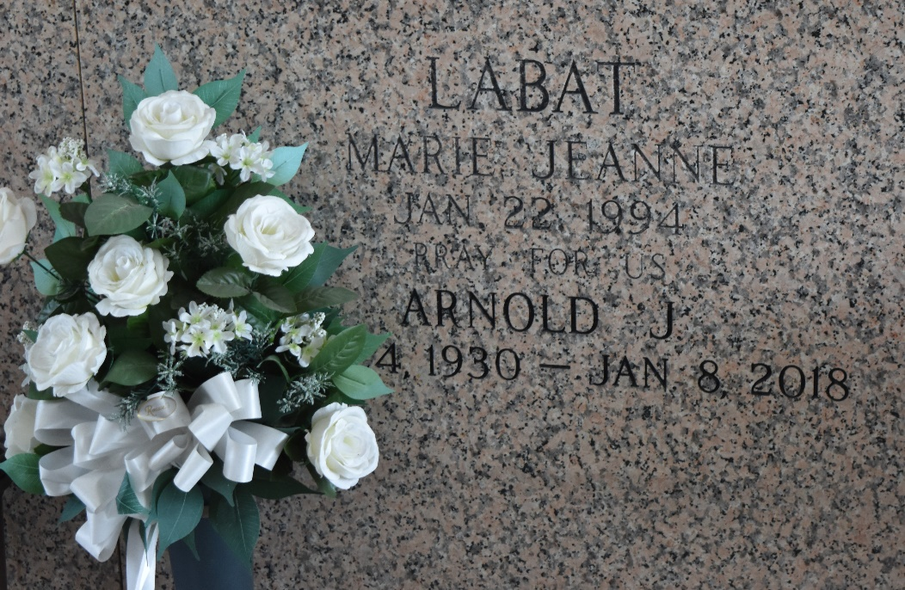

Arnold J. Labat, 87, of LaPlace, passed away peacefully at his home on Monday, January 8, 2018 surrounded by his family and his loving wife Geraldine Bleakley Labat of 68 years. He was preceded in death by his parents Joseph and Mary Guercio Labat, two granddaughters, and a son-in-law. He is survived by his three sisters Noeline Satterlee, Rose Mary Evans and Sarah Abbatiello, his seven children Terry Labat (Trudy), Stephanie Morris (the late Paul), Mary Jo D’Amico (Anthony), Richard Labat (Elsie), Jill Vicknair (Darren), Toni Ruiz (Todd), and Hollie Faucheux (Lenny), twenty-three grandchildren, and twenty-four great grandchildren.
Arnold was born in White Castle, LA and grew up in LaPlace. He graduated from Leon Godchaux High School. He worked at Shell Oil Refinery in Norco and retired after 30 years to begin his political career as St. John the Baptist Parish’s first Parish President. Because of his love for his community and the people of St. John the Baptist Parish, he served as Parish President for three terms. He served as Assistant Scout Master for Troop 312 as well as the Tri Parish Scouting District Chairman. He was awarded one of scouting’s highest honors, the Silver Beaver, for his distinguished service to youth. He was awarded V.F.W. Citizen of the Year in 1968. He was one of the founding fathers of Larayo, coordinated the first Mardi Gras Parade in LaPlace, and proudly served as King Allovus III. He was a lifelong member of St. Joan of Arc Church Parish.
Visitation will be held at Millet-Guidry Funeral Home, 2806 W. Airline Hwy, LaPlace, LA on Thursday evening, January 11, 2018 from 6:00 p.m. to 9:00 p.m. and on Friday morning, January 12, 2018 at St. Joan of Arc Catholic Church, 529 West Fifth St., LaPlace, LA from 9:00 a.m. to 12:00 noon. The Catholic Funeral Mass will follow visitation at 12:00 noon. A private interment will be held at a later date.

Millet-Guidry Funeral Home, LaPlace, Louisiana

