Daniel John Labat
August 5, 1931 - December 17, 2019
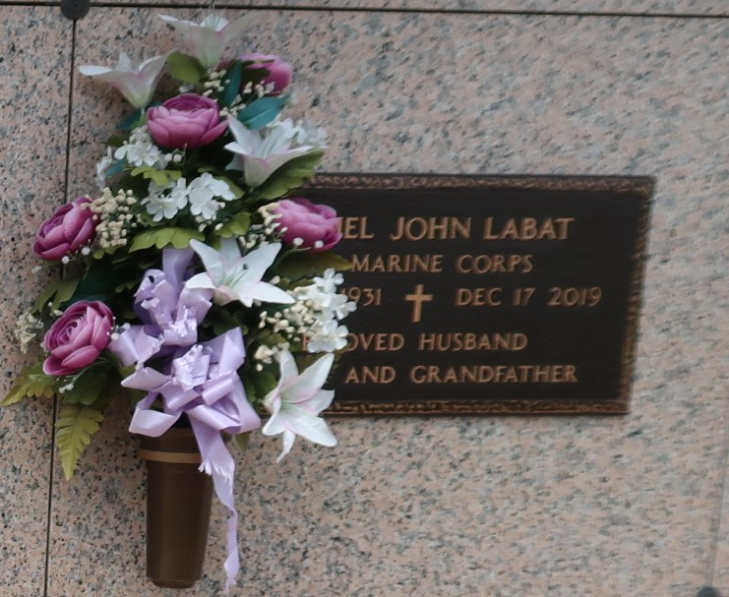

Daniel John Labat passed away on Tuesday, December 17, 2019 at the age of 88. He was a native and longtime resident of LaPlace. Daniel proudly served in the
U. S. Marine Corps during the Korean War and later was employed for over 34 years with Shell Oil Company. He was a member of the Knights of Columbus in LaPlace, member and past King of the Krewe of Allovus, a lifelong parishioner of St. Joan of Arc Catholic Church in LaPlace. Daniel loved his family, fishing, biking and LSU Football.
Beloved husband of 64 years to Jacqueline Brignac Labat. Loving father of Jody L. Duhe (Jack), Dana Labat, Tammy L. Richard (the late, Randy), Darren Labat (Colleen), Janelle L. Roy (Stephen), and Kyle Labat. Grandfather of Joseph Duhe (Staci), Matthew Duhe, Nathan Duhe (Anna), Angelle L. Osborne, Dylan Labat, Raegan Labat, Elizabeth Labat, Samuel Richard, Jacob Richard, Catherine Richard, Danielle Martin, Ashley Sandoval (Joshua), Jimmy Clayson, Ashley C. Soto (Ryan), Katelyn O. Ammon (Brandon), Austin Roy, Alex Roy, Taylor Labat (Rae), Sarah Labat, Julia Labat, and Caroline Labat. Great grandfather of 14.
Daniel was preceded in death by his parents, Lawrence Labat and Elsie Gautreaux Labat Madere; brothers, Leroy Labat, Gerald Labat; and sisters, Thelma Cheek and Verna McTyre. He is also survived by many nieces and nephews.
Relatives and friends are invited to attend the visitation at St. Joan of Arc Catholic Church, 529 W. 5th Street, LaPlace on Saturday, December 21, 2019 from 8:30 a.m. until 10:30 a.m. followed by the Funeral Mass at 10:30 a.m. Interment in St. John Memorial Gardens Cemetery. In lieu of flowers, Masses preferred or please consider a donation in his memory to the charity of your choice.
Millet-Guidry Funeral Home, LaPlace, Louisiana
December 19, 2019

