Marguerite M. Lacoste
February 21, 1922 – October 20, 2000
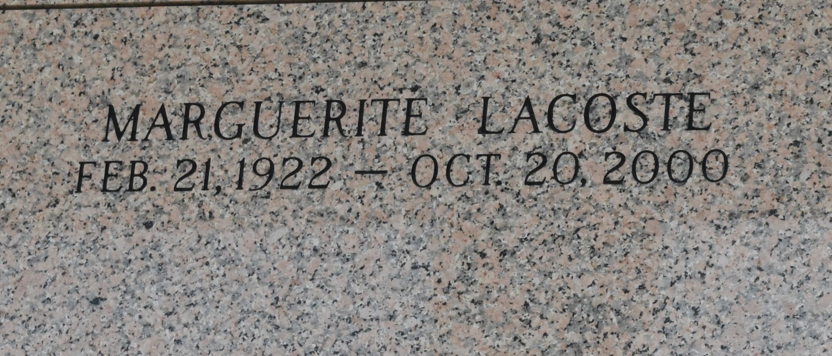

LAPLACE - Marguerite M. Lacoste, 78, a native of New Orleans and resident of LaPlace for 13 years, died Oct. 20. She was the daughter of the late Andre and Loretto Lazare Lacosta and sister of Andrea and Andre Lacoste, and the late Emile Lacoste.

Services are today at 10 a.m. at Ascension of Our Lord Catholic Church, LaPlace, with interment at St. John Memorial Gardens, LaPlace. Visitation starts at 8 a.m.
L'Observateur, LaPlace, Louisiana
October 25, 2000

