Betty Jo (Norsworthy) Laiche
October 14, 1937 ~ October 6, 2021

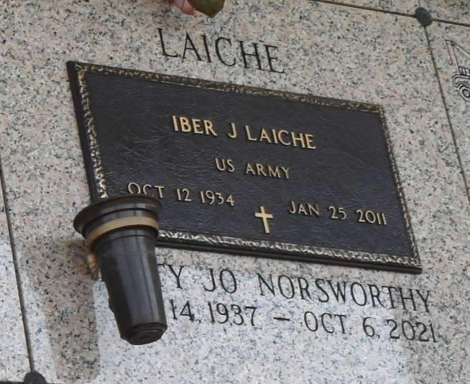

Betty Jo Norsworthy Laiche peacefully transitioned at the age of 83 on Wednesday October 6, 2021. Daughter of Robert Lee and Mildred Norsworthy. Beloved wife of the late Iber J. Laiche, Jr. Beloved mother of Grace L. Guerin (Eliot), Robert Laiche (Jodi) and Anne L. Milneck (Greg). Beloved Grandmother of Eliot, Jr., and Justin Guerin, Ryan, Lauren, and Julia Laiche, Alexis M. Edwards, Clay, and Emma Milneck. Beloved sister of Celia Ann Norsworthy and the late William Norsworthy. A native of Mer Rouge, LA, and a resident of LaPlace, LA.
She graduated from Northeast Louisiana University, Monroe, LA. She then worked as a Home Demonstration agent with Louisiana Power and Light. Dietitian, a Real Estate Agent, and she was a kindergarten teacher at St. Joan of Arc Catholic School. She spent her retirement years as a part time Librarian and full-time grandmother.
Relatives and friends of the family are invited to attend the funeral Mass at St. Joan of Arc Catholic Church, West 5th Street, LaPlace, LA at 1:00pm on Saturday, October 9, 2021. Visitation at St. Joan of Arc Catholic Church on Saturday October 9, 2021 from 11:00am until mass time. In accordance with the CDC Guidelines for COVID-19 all in attendance must wear a mask and practice social distancing. Interment in St. John Memorial Gardens, LaPlace, LA. Special thanks to caregivers Barbara, Kush, Valerie, and Dr. Andy St. Martin. Final Arrangements entrusted to Patrick H. Sanders Funeral Home & Funeral Directors, Inc. 605 Main Street, LaPlace, LA. For information 985-359-1919.
The Patrick H. Sanders Funeral Home, LaPlace, Louisiana

